**Challenge 10 - ER diagram with SQL queries**

**Creating database tables:**

CREATE TABLE movie (

id INT PRIMARY KEY,

name VARCHAR(255),

premiere_city VARCHAR(255),

genre VARCHAR(32),

country_of_origin VARCHAR(255),

production_company VARCHAR(255)

)

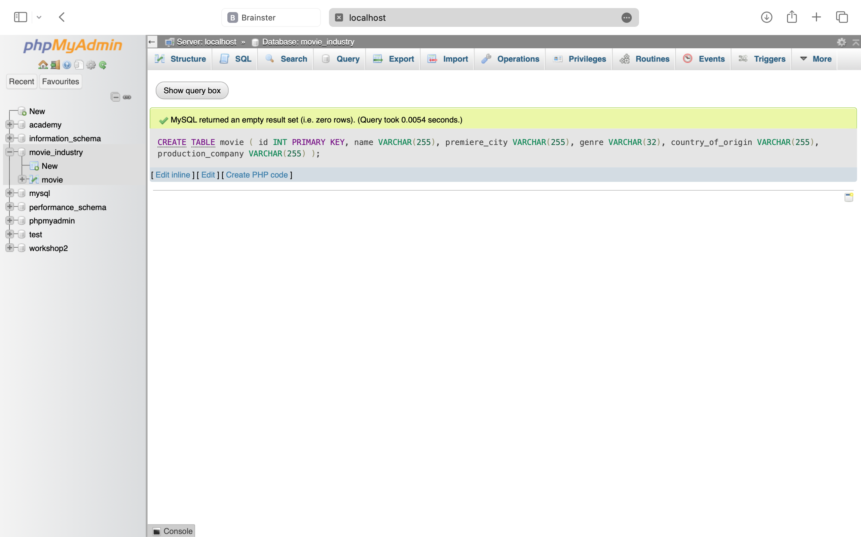

CREATE TABLE film (

movie_id INT PRIMARY KEY,

first_week_profit DOUBLE,

premiere_format VARCHAR(10),

FOREIGN KEY (movie_id) REFERENCES movie(id)

)

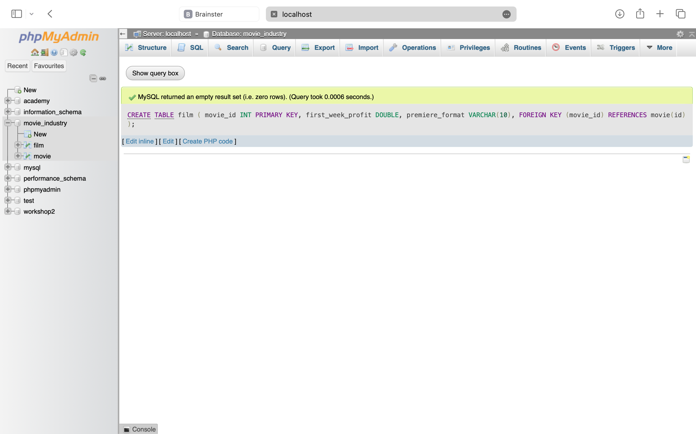

CREATE TABLE tv_series (

movie_id INT PRIMARY KEY,

tv_channel VARCHAR(255),

number_of_episodes INT,

number_of_seasons INT,

FOREIGN KEY (movie_id) REFERENCES movie(id)

)



CREATE TABLE sequel (

id INT PRIMARY KEY,

movie_id INT,

number_of_sequels INT,

FOREIGN KEY (movie_id) REFERENCES movie(id)

)



CREATE TABLE actor (

id INT PRIMARY KEY,

first_name VARCHAR(255),

last_name VARCHAR(255),

nickname VARCHAR(255),

date_of_birth DATE,

agent_code VARCHAR(255)

)

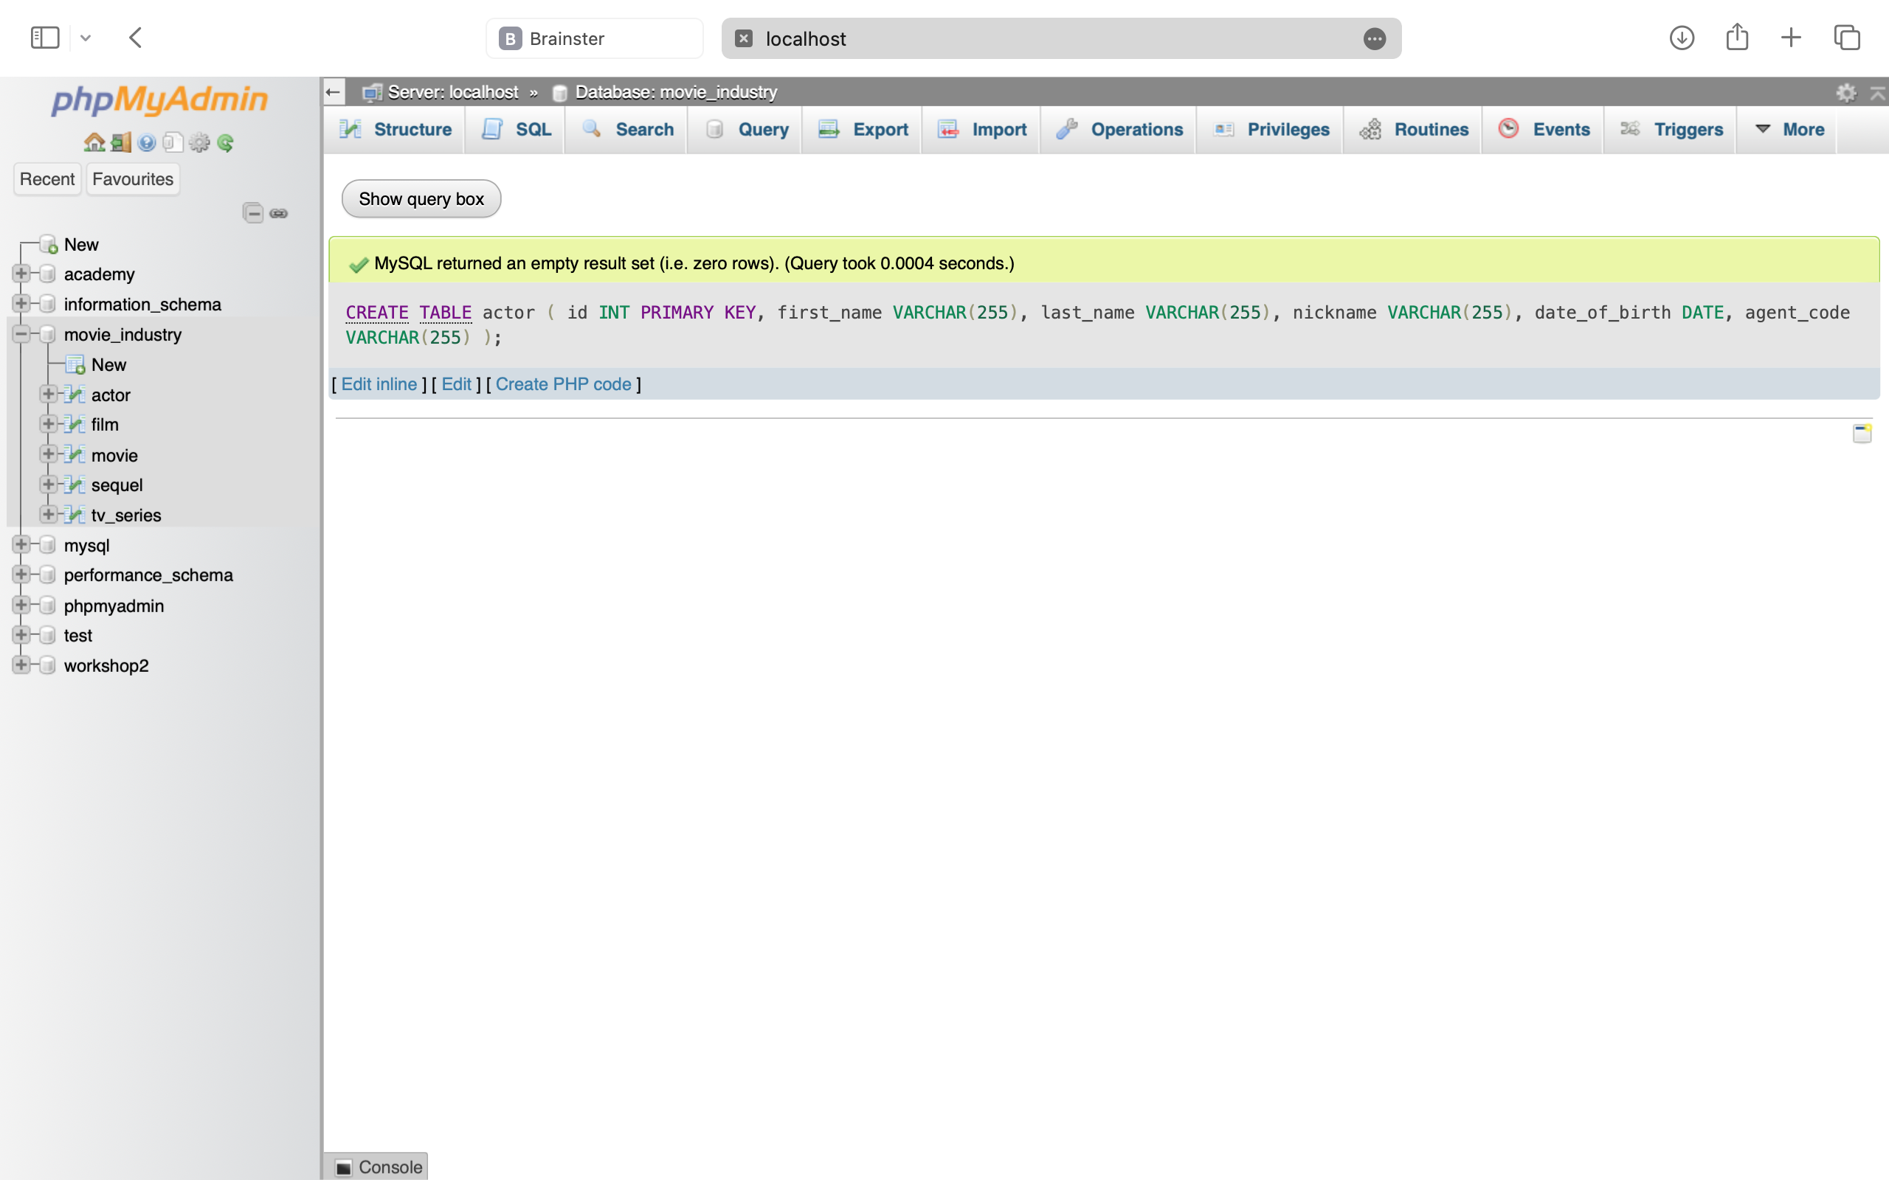

CREATE TABLE regular_actor (

actor_id INT PRIMARY KEY,

FOREIGN KEY (actor_id) REFERENCES actor(id)

)



CREATE TABLE oscar_winner (

actor_id INT,

movie_id INT,

role VARCHAR(255),

year INT,

PRIMARY KEY (actor_id, movie_id),

FOREIGN KEY (actor_id) REFERENCES actor(id),

FOREIGN KEY (movie_id) REFERENCES film(movie_id)

)

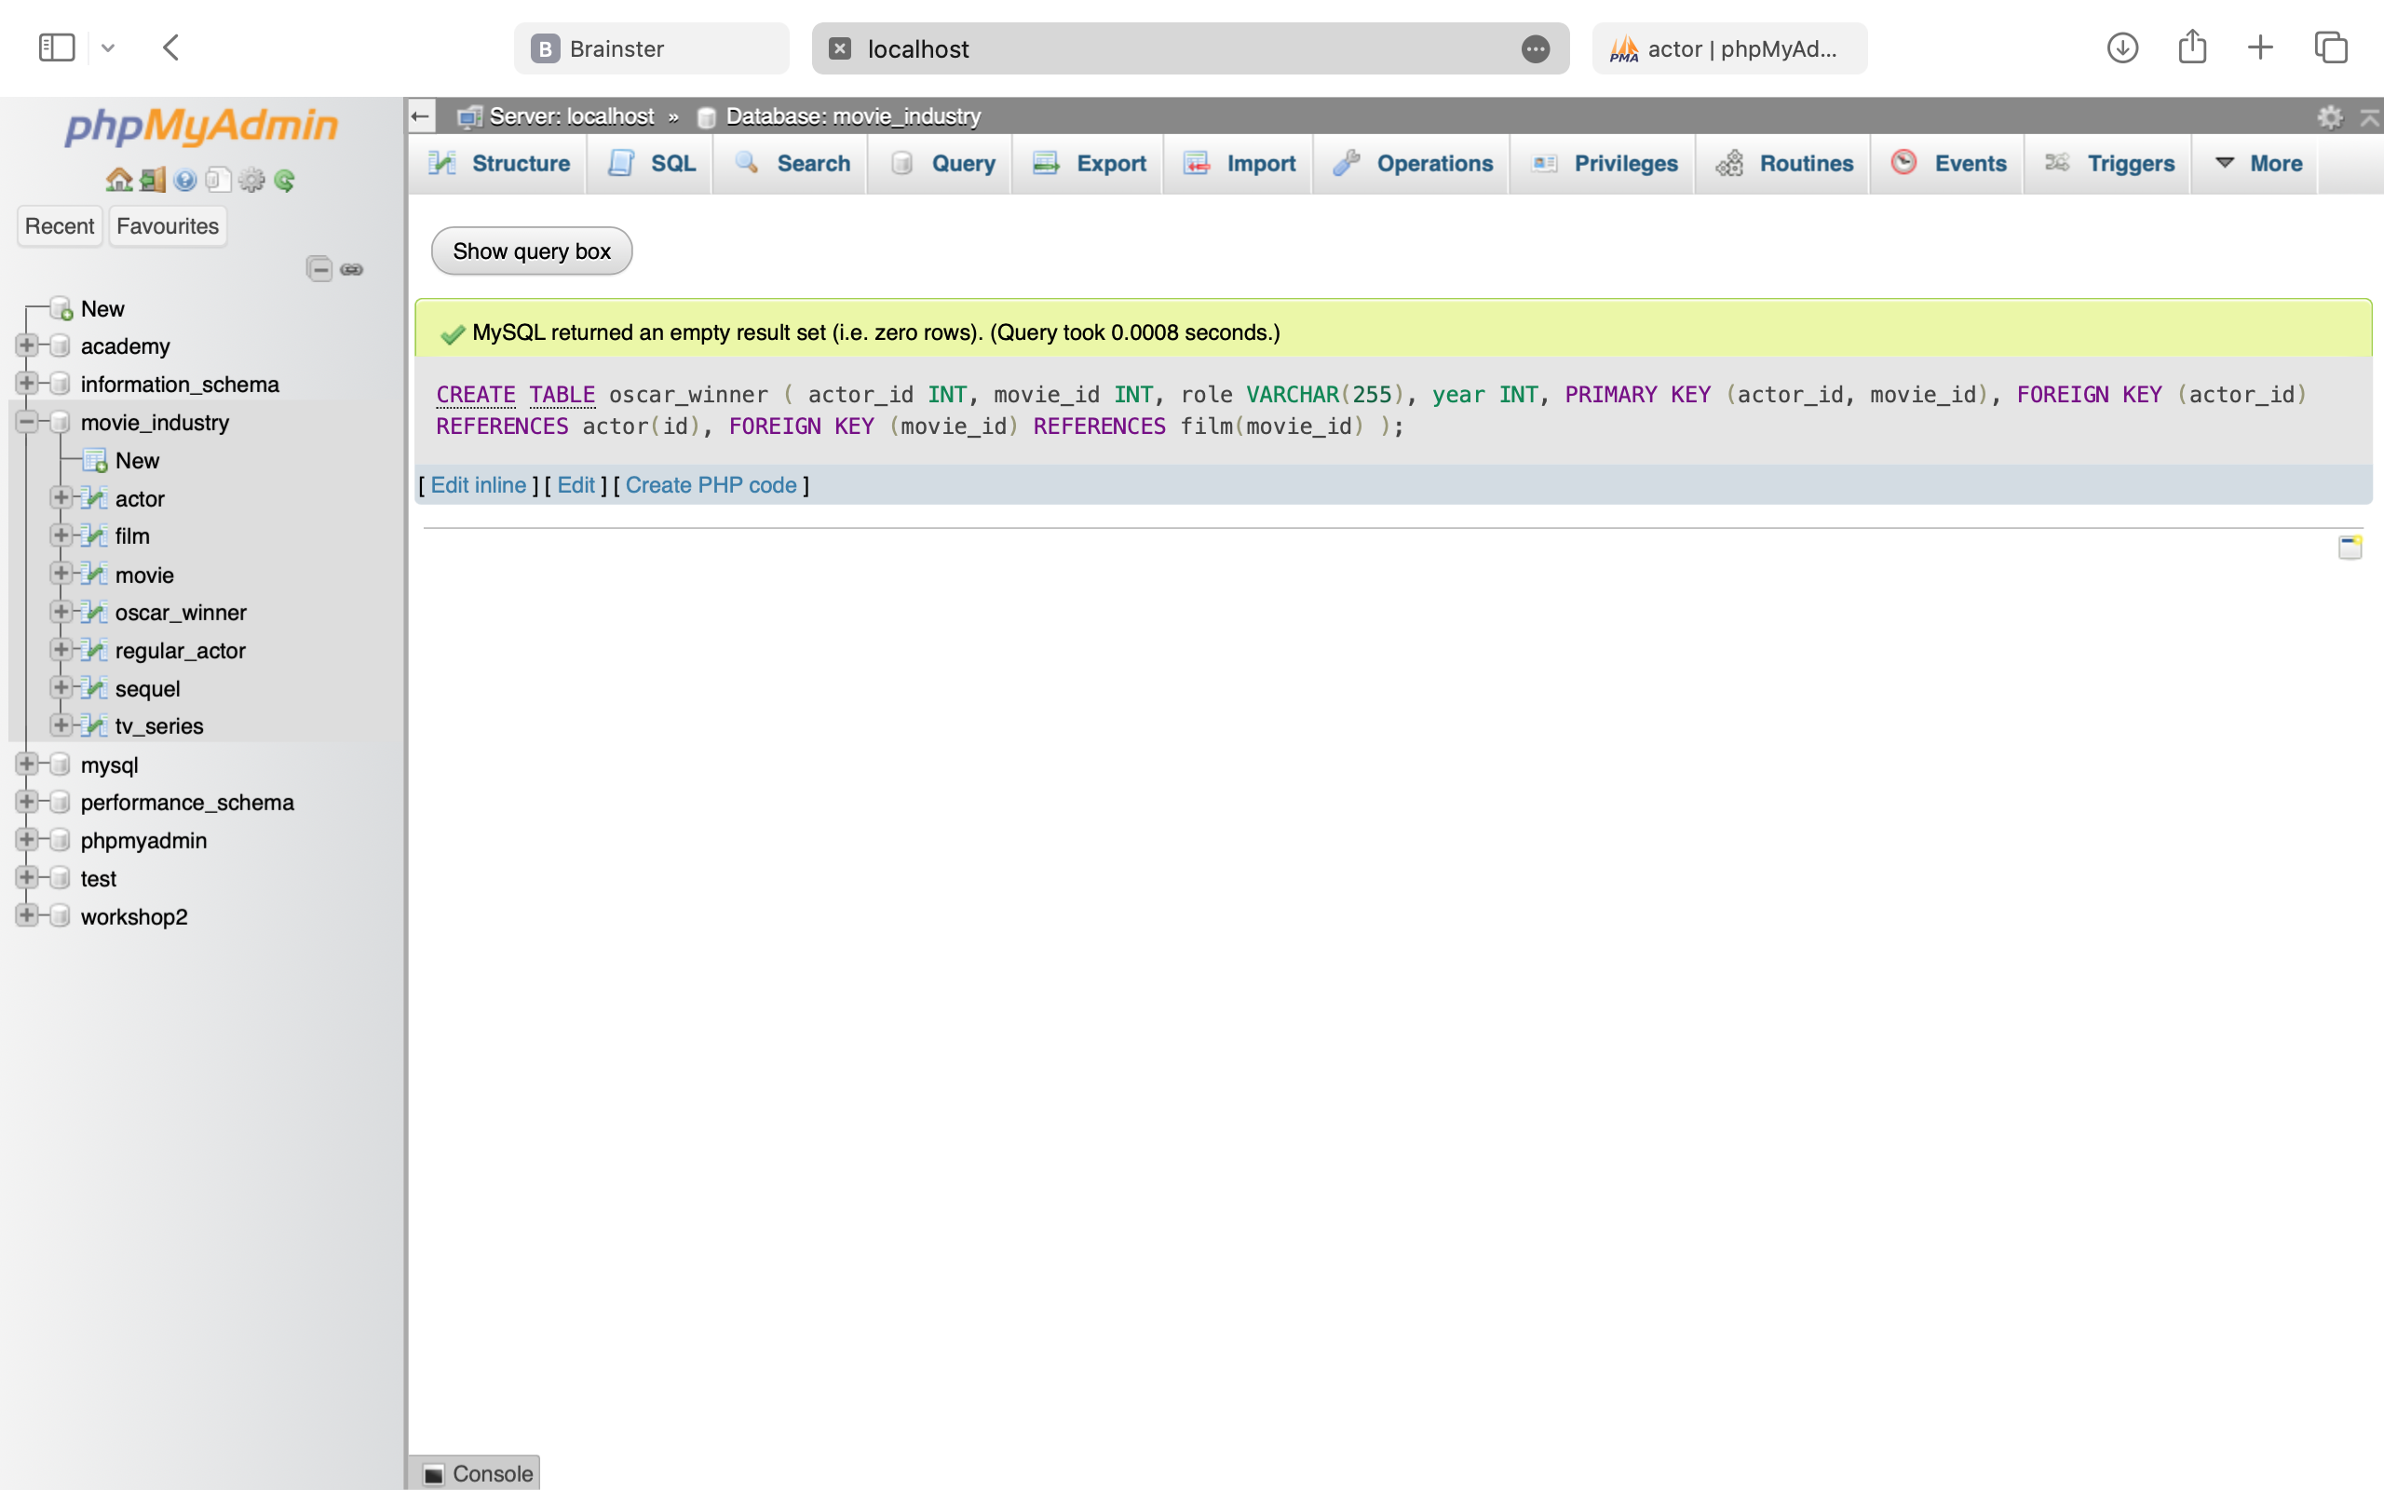

CREATE TABLE movie_actor (

movie_id INT,

actor_id INT,

payment DOUBLE,

PRIMARY KEY (movie_id, actor_id),

FOREIGN KEY (movie_id) REFERENCES movie(id),

FOREIGN KEY (actor_id) REFERENCES actor(id)

)

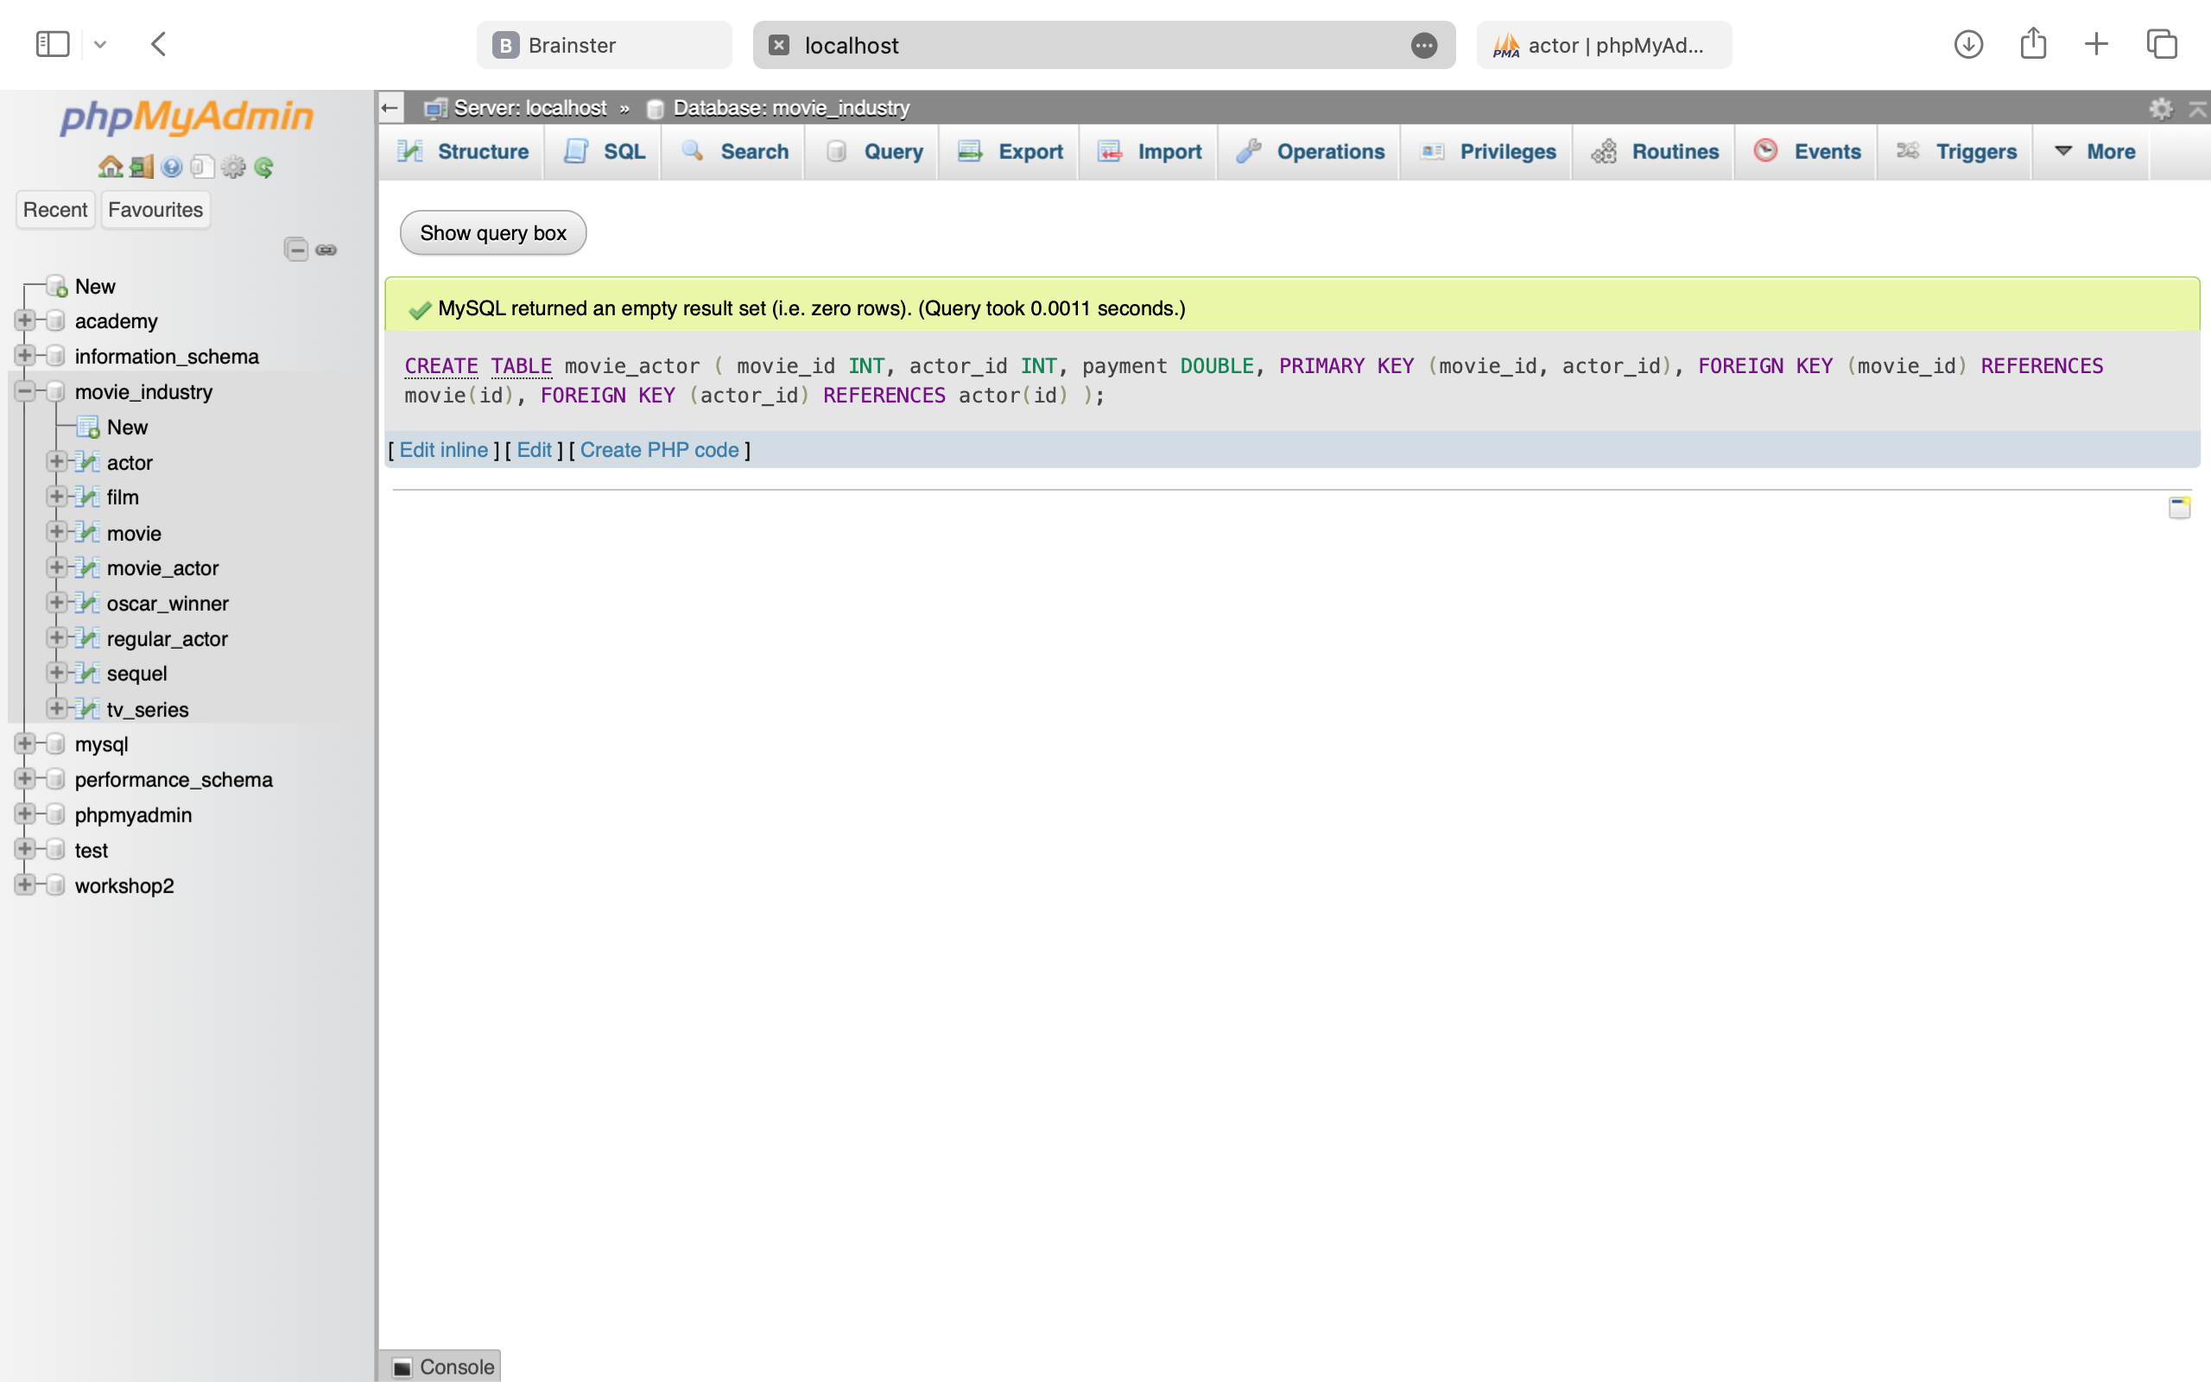

CREATE TABLE director (

id INT PRIMARY KEY,

first_name VARCHAR(100),

last_name VARCHAR(100),

genre VARCHAR(100),

expertise VARCHAR(255),

film_id INT,

FOREIGN KEY (film_id) REFERENCES film(movie_id)

)



CREATE TABLE critic (

id INT PRIMARY KEY,

first_name VARCHAR(255),

last_name VARCHAR(255),

username VARCHAR(255),

password VARCHAR(255)

)



CREATE TABLE movie_critic (

movie_id INT,

critic_id INT,

rating DECIMAL(3, 1),

PRIMARY KEY (movie_id, critic_id),

FOREIGN KEY (movie_id) REFERENCES movie(id),

FOREIGN KEY (critic_id) REFERENCES critic(id)

)

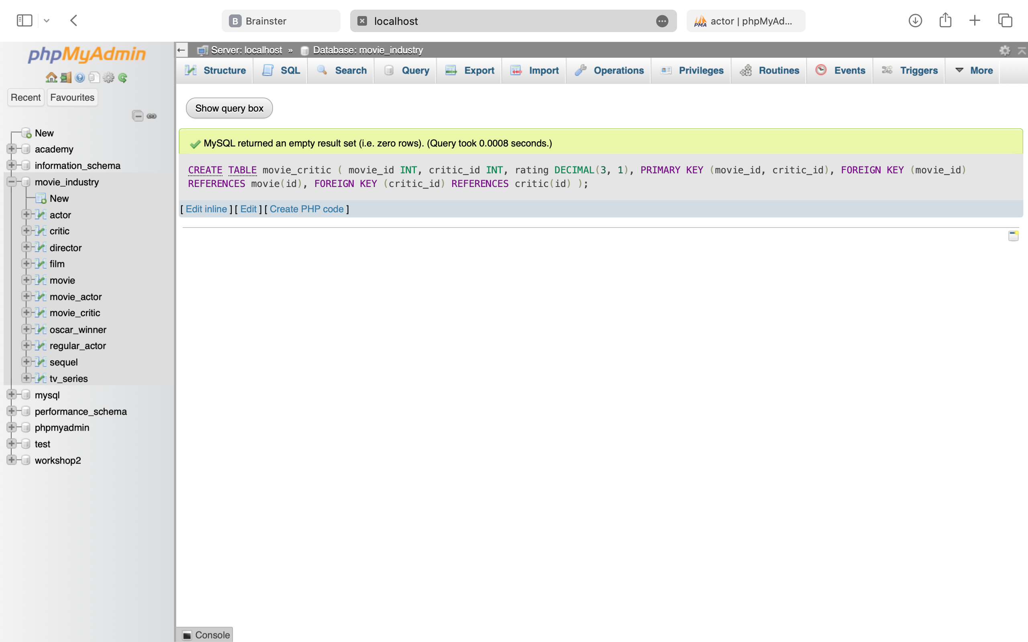

CREATE TABLE actor_critique (

movie_id INT,

critic_id INT,

actor_id INT,

acting_grade DECIMAL(3, 1),

expression_grade DECIMAL(3, 1),

naturalness_grade DECIMAL(3, 1),

devotion_grade DECIMAL(3, 1),

PRIMARY KEY (movie_id, critic_id, actor_id),

FOREIGN KEY (movie_id) REFERENCES movie(id),

FOREIGN KEY (critic_id) REFERENCES critic(id),

FOREIGN KEY (actor_id) REFERENCES actor(id)

)

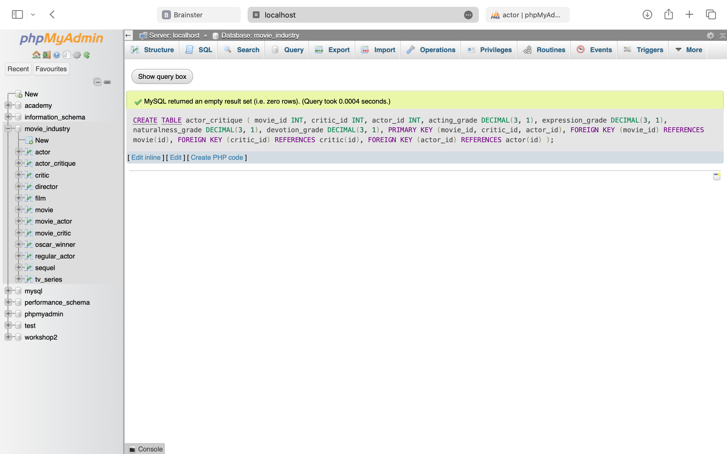

**Populating database tables:**

INSERT INTO movie (id, name, premiere_city, genre, country_of_origin, production_company)

VALUES

(1, 'Shutter Island', 'New York', 'Thriller', 'USA', 'Paramount Pictures'),

(2, 'Fight Club', 'Los Angeles', 'Drama', 'USA', 'Fox 2000 Pictures'),

(3, 'Pulp Fiction', 'Cannes', 'Crime', 'USA', 'Miramax'),

(4, 'Once Upon A Time in Hollywood', 'Los Angeles', 'Comedy-Drama', 'USA', 'Columbia Pictures'),

(5, 'Wolf of Wall Street', 'New York', 'Biography', 'USA', 'Paramount Pictures'),

(6, 'Gossip Girl', 'New York', 'Drama', 'USA', 'Warner Bros.'),

(7, 'Sex and the City', 'New York', 'Romance', 'USA', 'HBO'),

(8, 'Breaking Bad', 'Albuquerque', 'Crime', 'USA', 'AMC'),

(9, 'One Tree Hill', 'Wilmington', 'Drama', 'USA', 'Warner Bros.'),

(10, 'Money Heist', 'Madrid', 'Action', 'Spain', 'Vancouver Media')

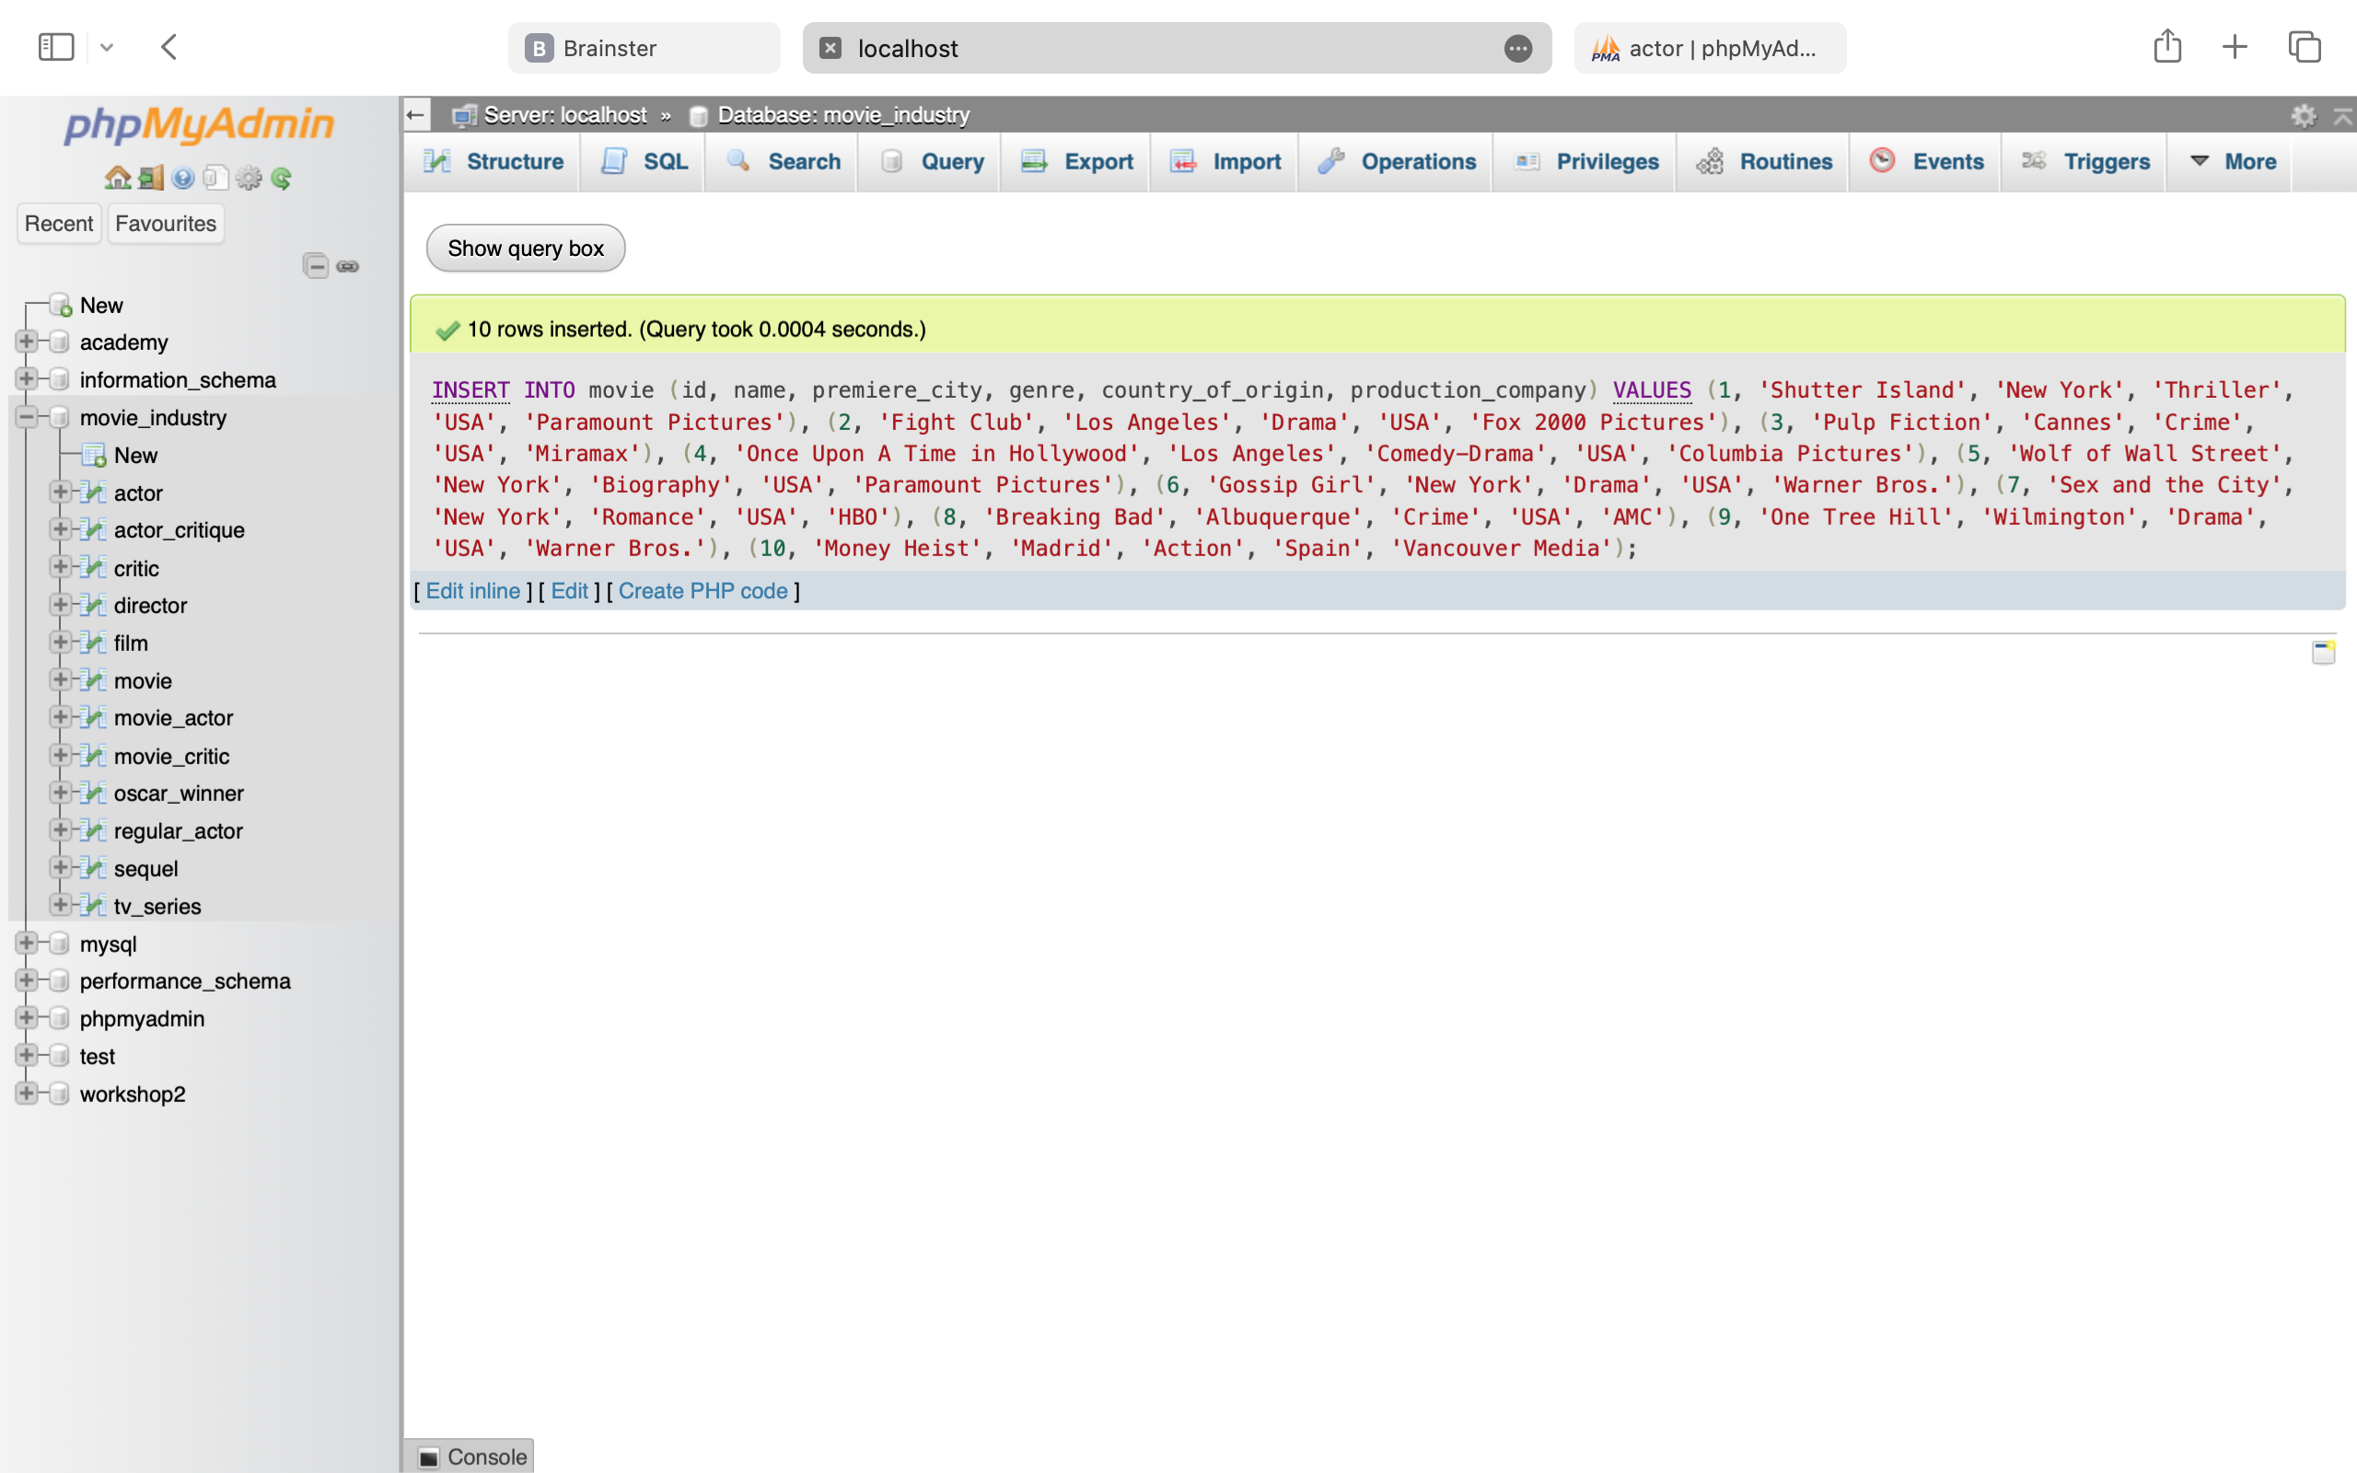

INSERT INTO film (movie_id, first_week_profit, premiere_format)

VALUES

(1, 41.0, '2D'),

(2, 37.0, '2D'),

(3, 9.3, '3D'),

(4, 41.1, '2D'),

(5, 18.4, '3D')

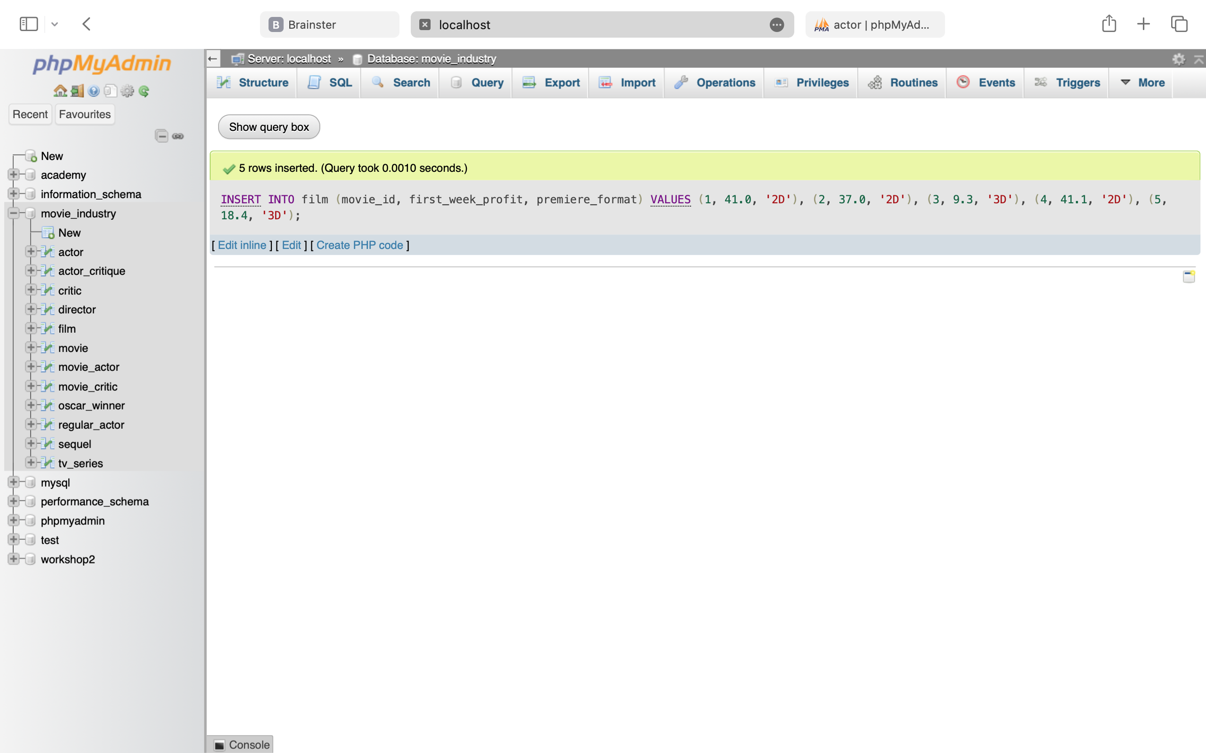

INSERT INTO tv_series (movie_id, tv_channel, number_of_episodes, number_of_seasons)

VALUES

(6, 'The CW', 121, 6),

(7, 'HBO', 94, 6),

(8, 'AMC', 62, 5),

(9, 'The WB', 187, 9),

(10, 'Netflix', 41, 5);

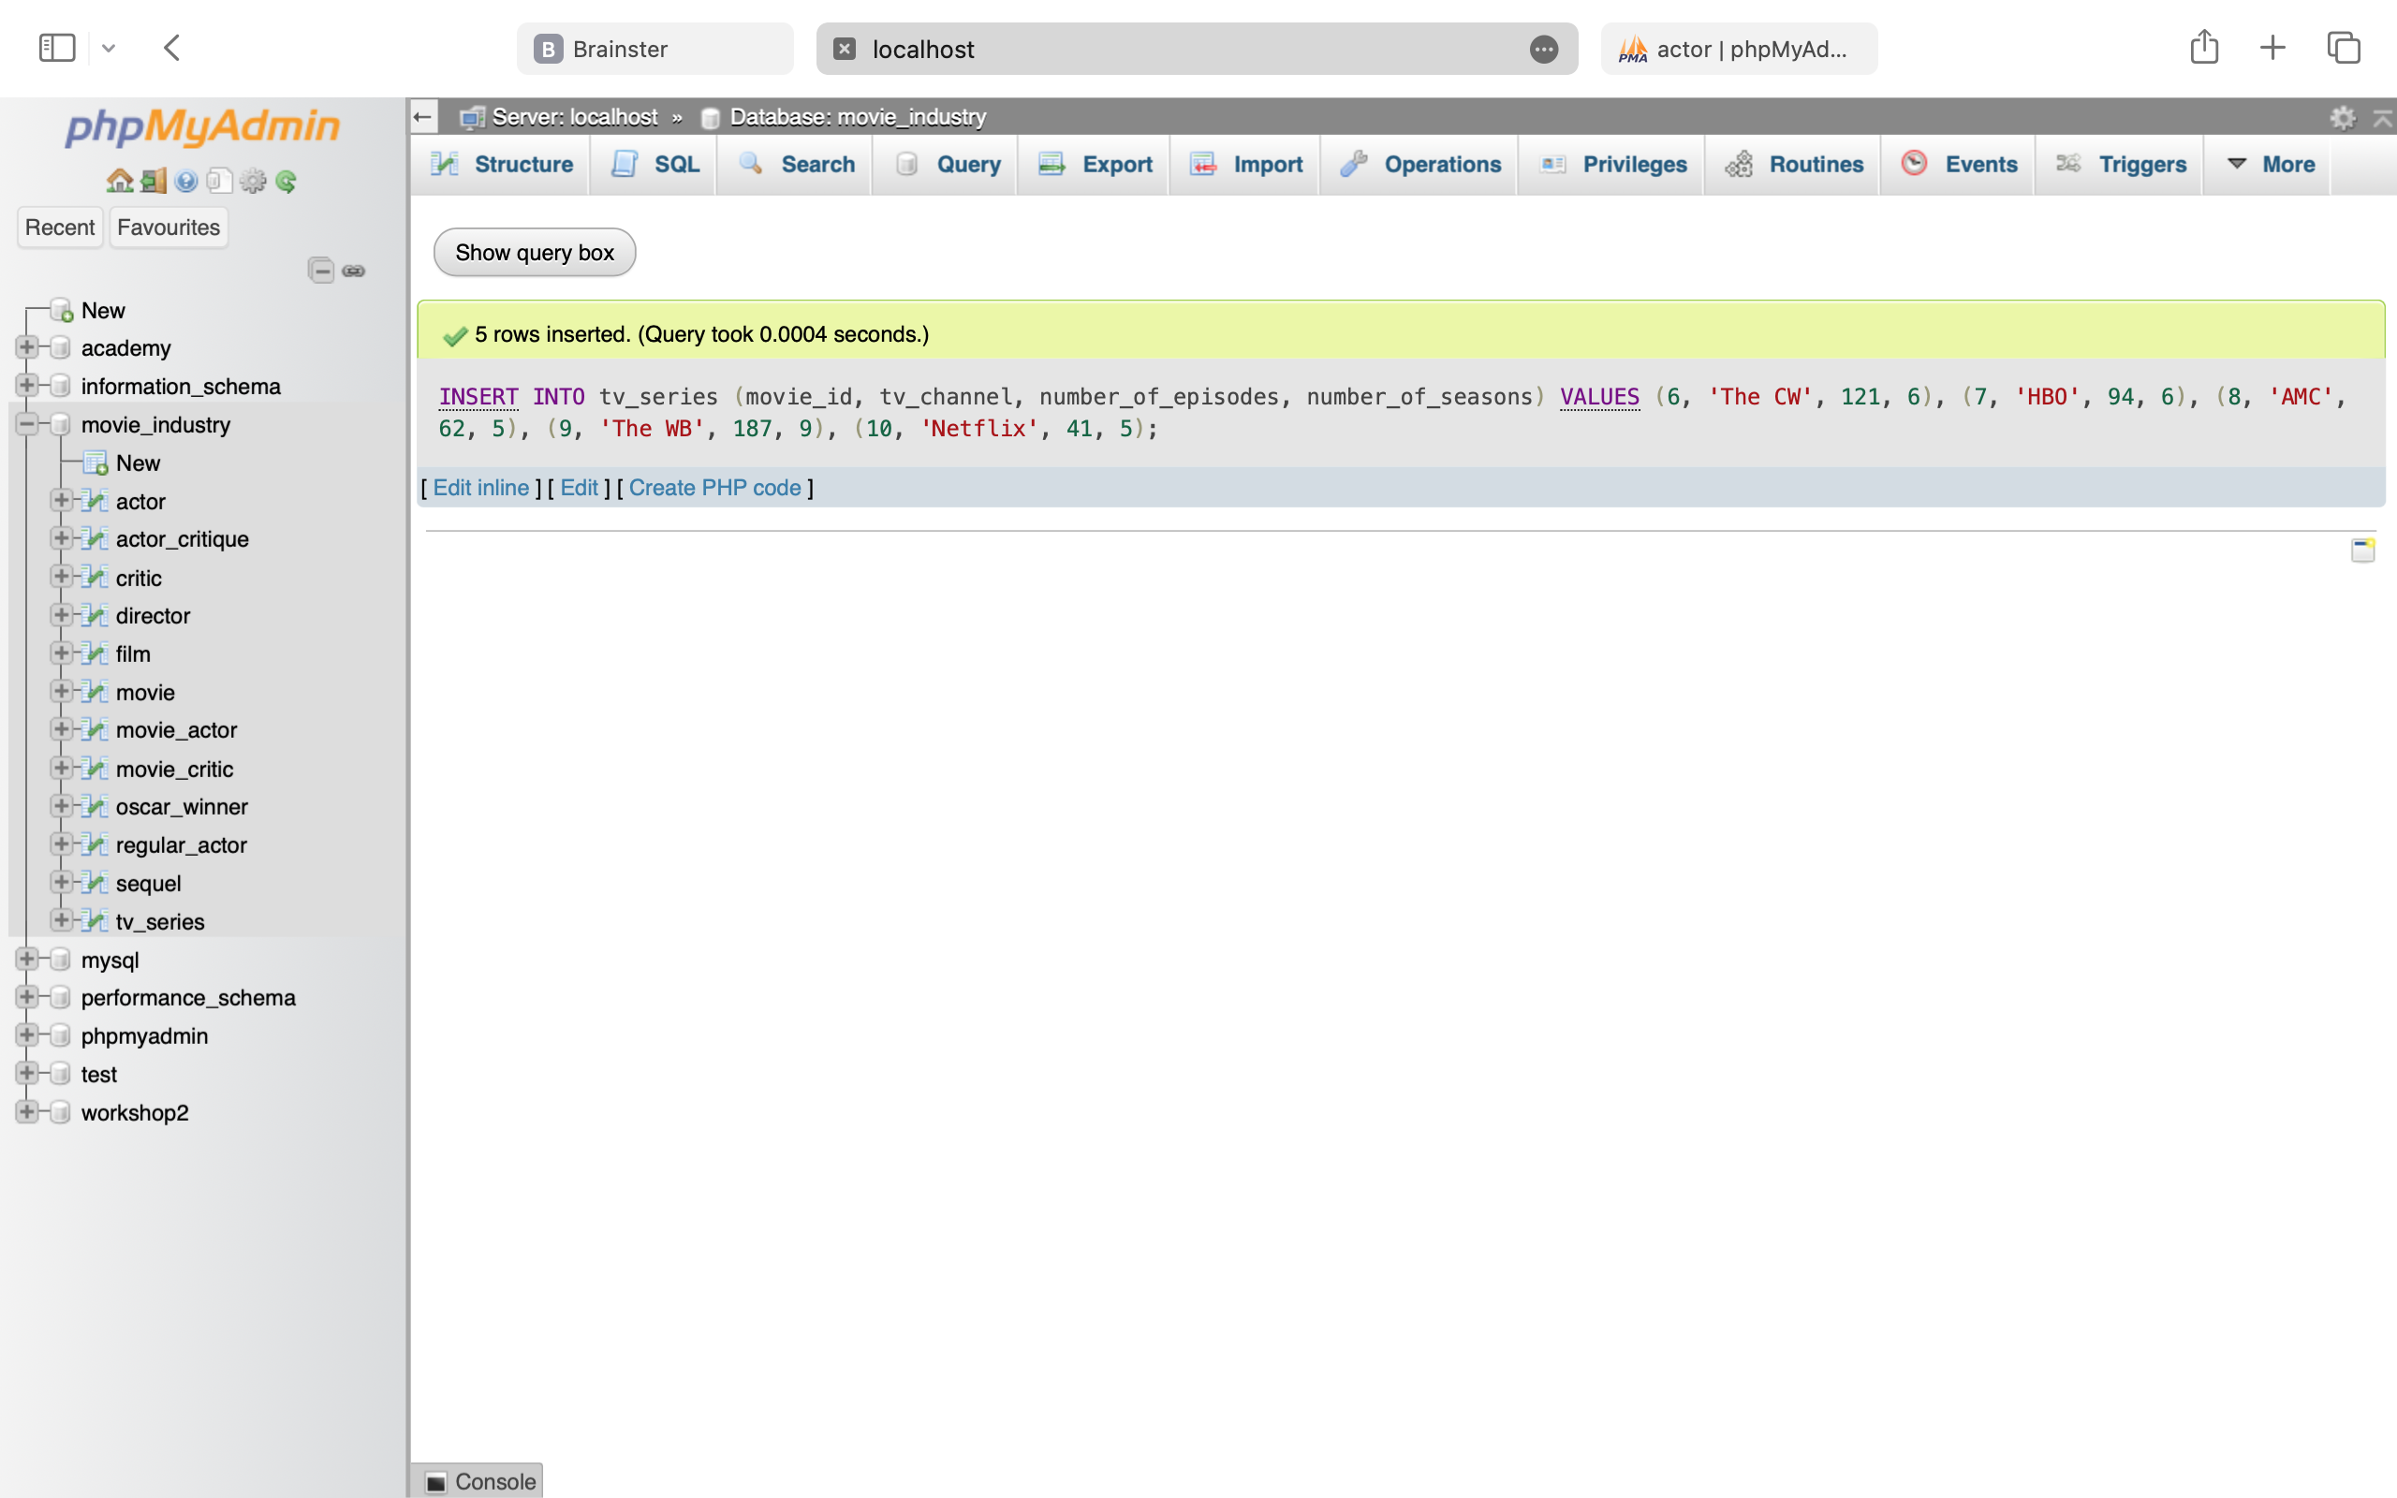

INSERT INTO sequel (id, movie_id, number_of_sequels)

VALUES

(1, 1, 0),

(2, 2, 0),

(3, 3, 1),

(4, 4, 0),

(5, 5, 1);

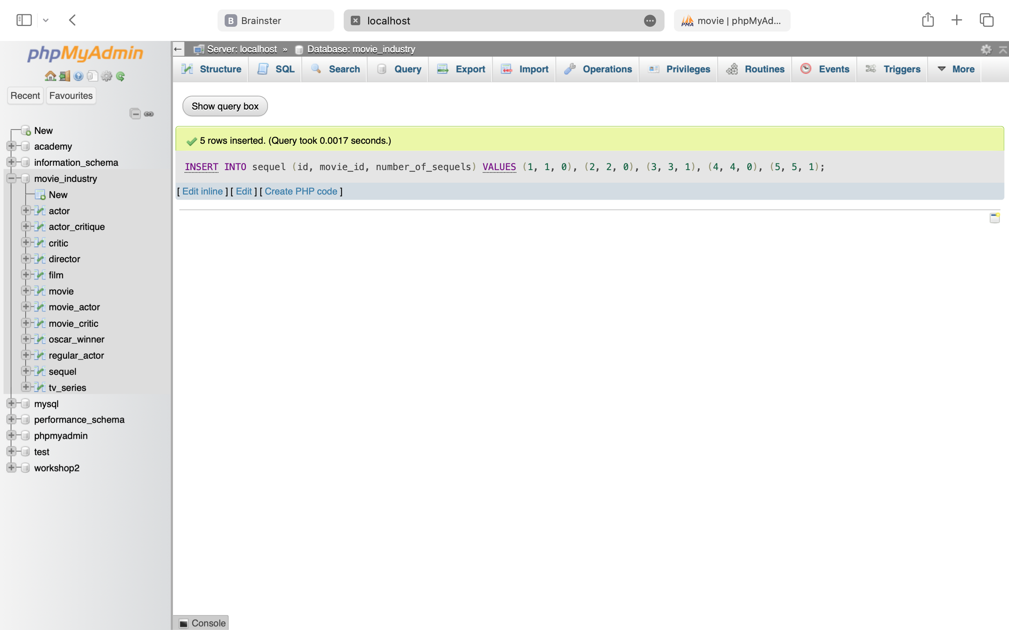

INSERT INTO actor (id, first_name, last_name, nickname, date_of_birth, agent_code)

VALUES

(1, 'Leonardo', 'DiCaprio', 'Leo', '1974-11-11', 'AG001'),

(2, 'Brad', 'Pitt', NULL, '1963-12-18', 'AG002'),

(3, 'Uma', 'Thurman', NULL, '1970-04-29', 'AG003'),

(4, 'Matthew', 'McConaughey', NULL, '1969-11-04', 'AG004'),

(5, 'Jessica', 'Chastain', NULL, '1977-03-24', 'AG005'),

(6, 'Tom', 'Hanks', 'Tommy', '1956-07-09', 'AG006'),

(7, 'Scarlett', 'Johansson', 'ScarJo', '1984-11-22', 'AG007'),

(8, 'Morgan', 'Freeman', 'Morg', '1937-06-01', 'AG008'),

(9, 'Natalie', 'Portman', NULL, '1981-06-09', 'AG009'),

(10, 'Johnny', 'Depp', NULL, '1963-06-09', 'AG010');

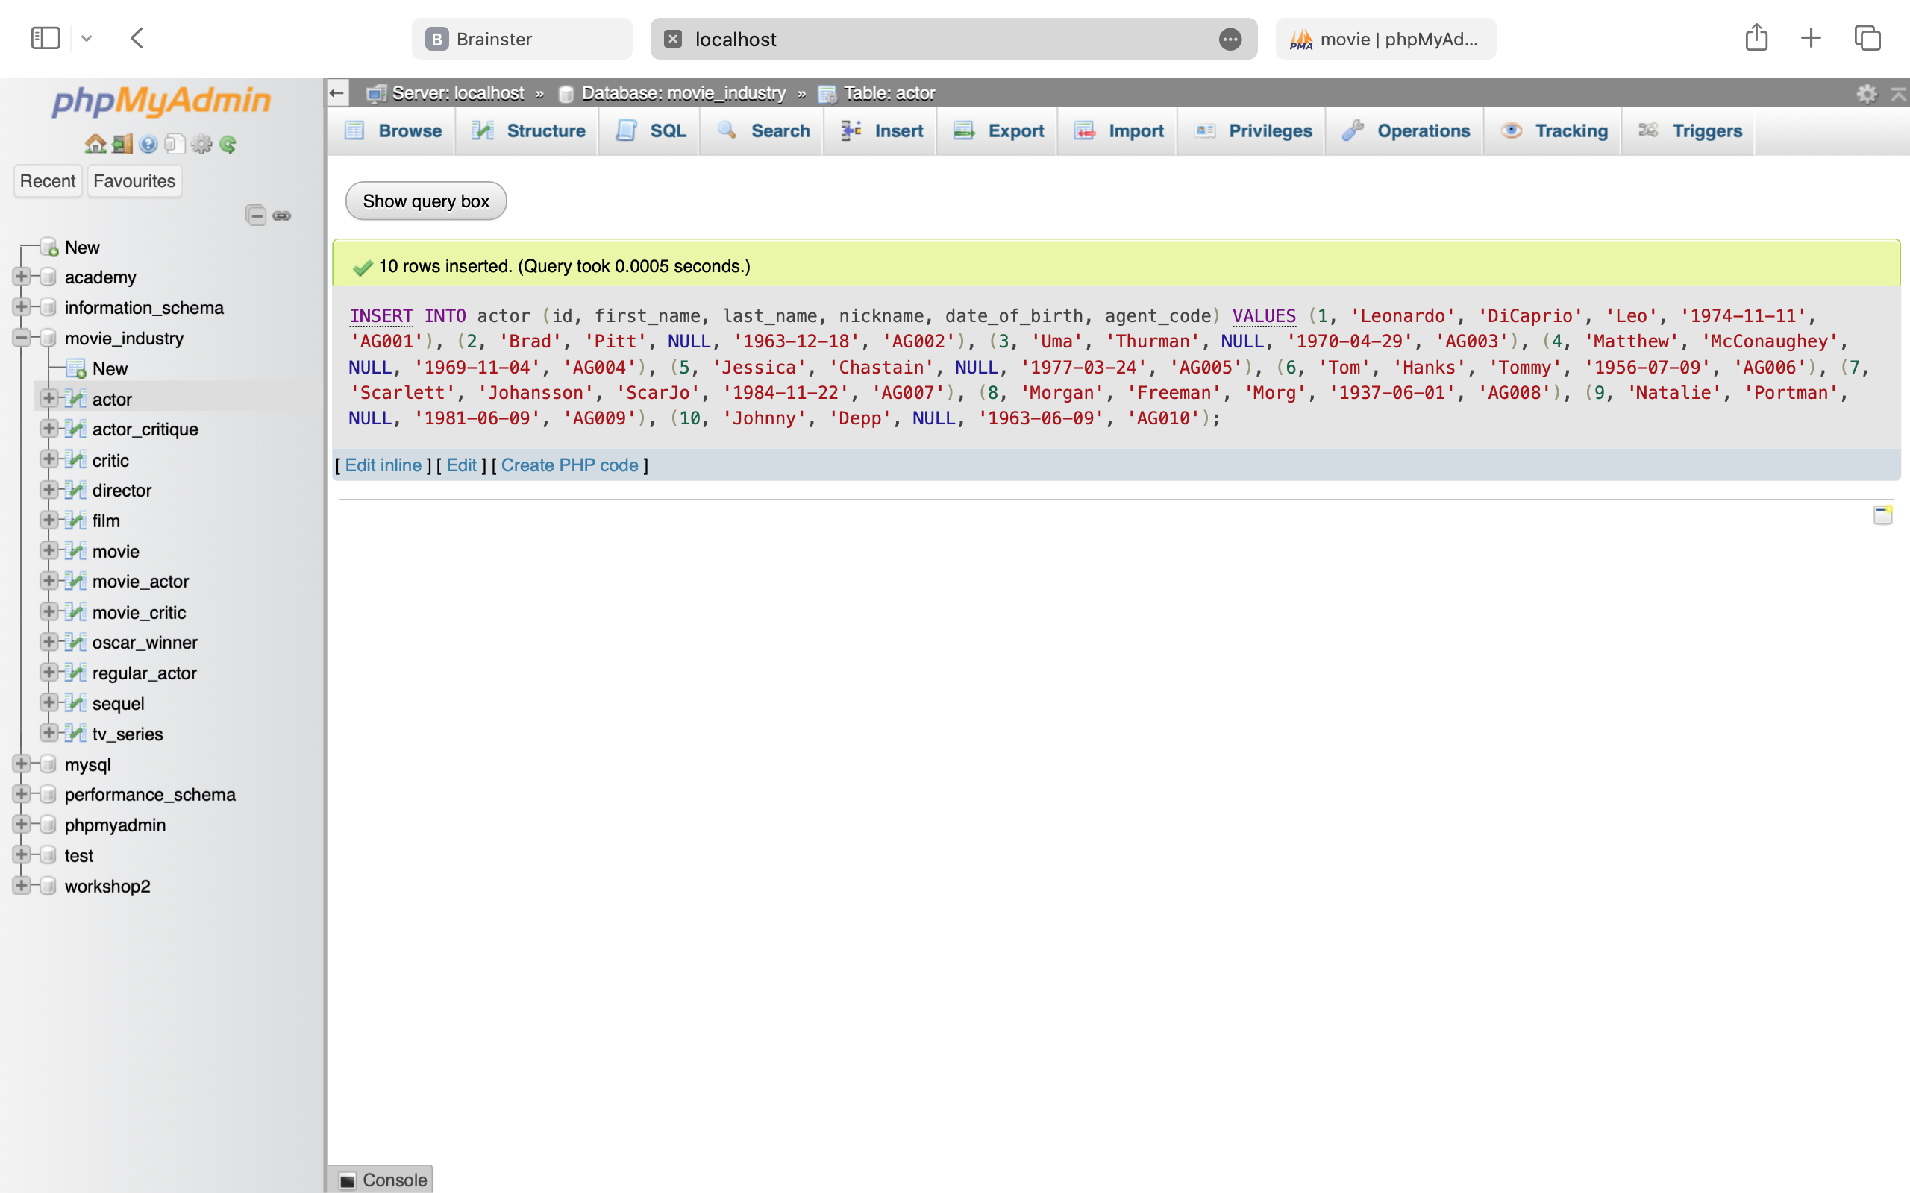

INSERT INTO oscar_winner (actor_id, movie_id, role, year)

VALUES

(1, 5, 'Jordan Belfort', 2014),

(2, 4, 'Cliff Booth', 2020),

(3, 3, 'Mia Wallace', 1995),

(4, 5, 'Mark Hanna', 2014),

(5, 1, 'Tammy Faye', 2010)

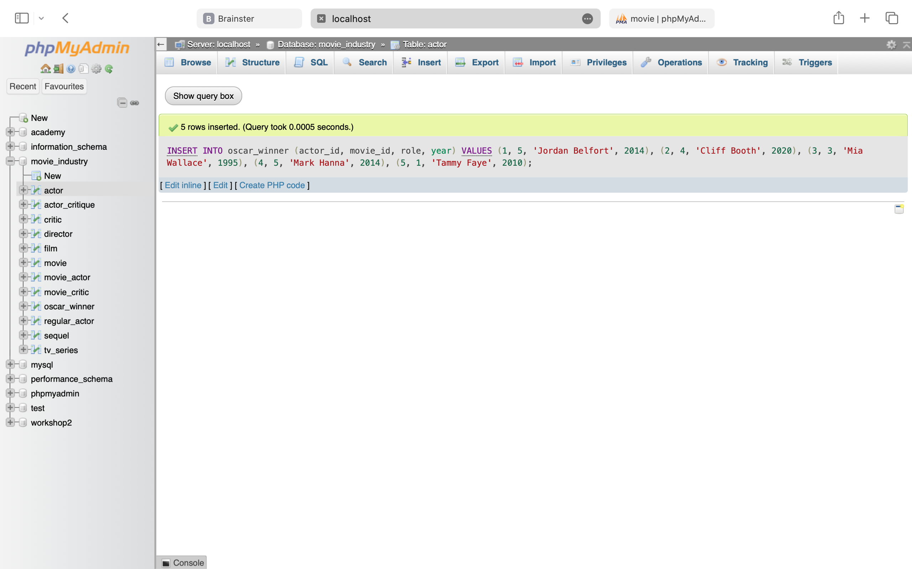

INSERT INTO regular_actor (actor_id)

VALUES

(6), (7), (8), (9), (10)



INSERT INTO director (id, first_name, last_name, genre, expertise, film_id)

VALUES

(1, 'Martin', 'Scorsese', 'Thriller', 'Psychological Thrillers', 1),

(2, 'David', 'Fincher', 'Drama', 'Dark Drama', 2),

(3, 'Quentin', 'Tarantino', 'Crime', 'Nonlinear Storytelling', 3),

(4, 'Quentin', 'Tarantino', 'Drama', 'Retro Homages', 4),

(5, 'Martin', 'Scorsese', 'Biography', 'Biographical Crime', 5)

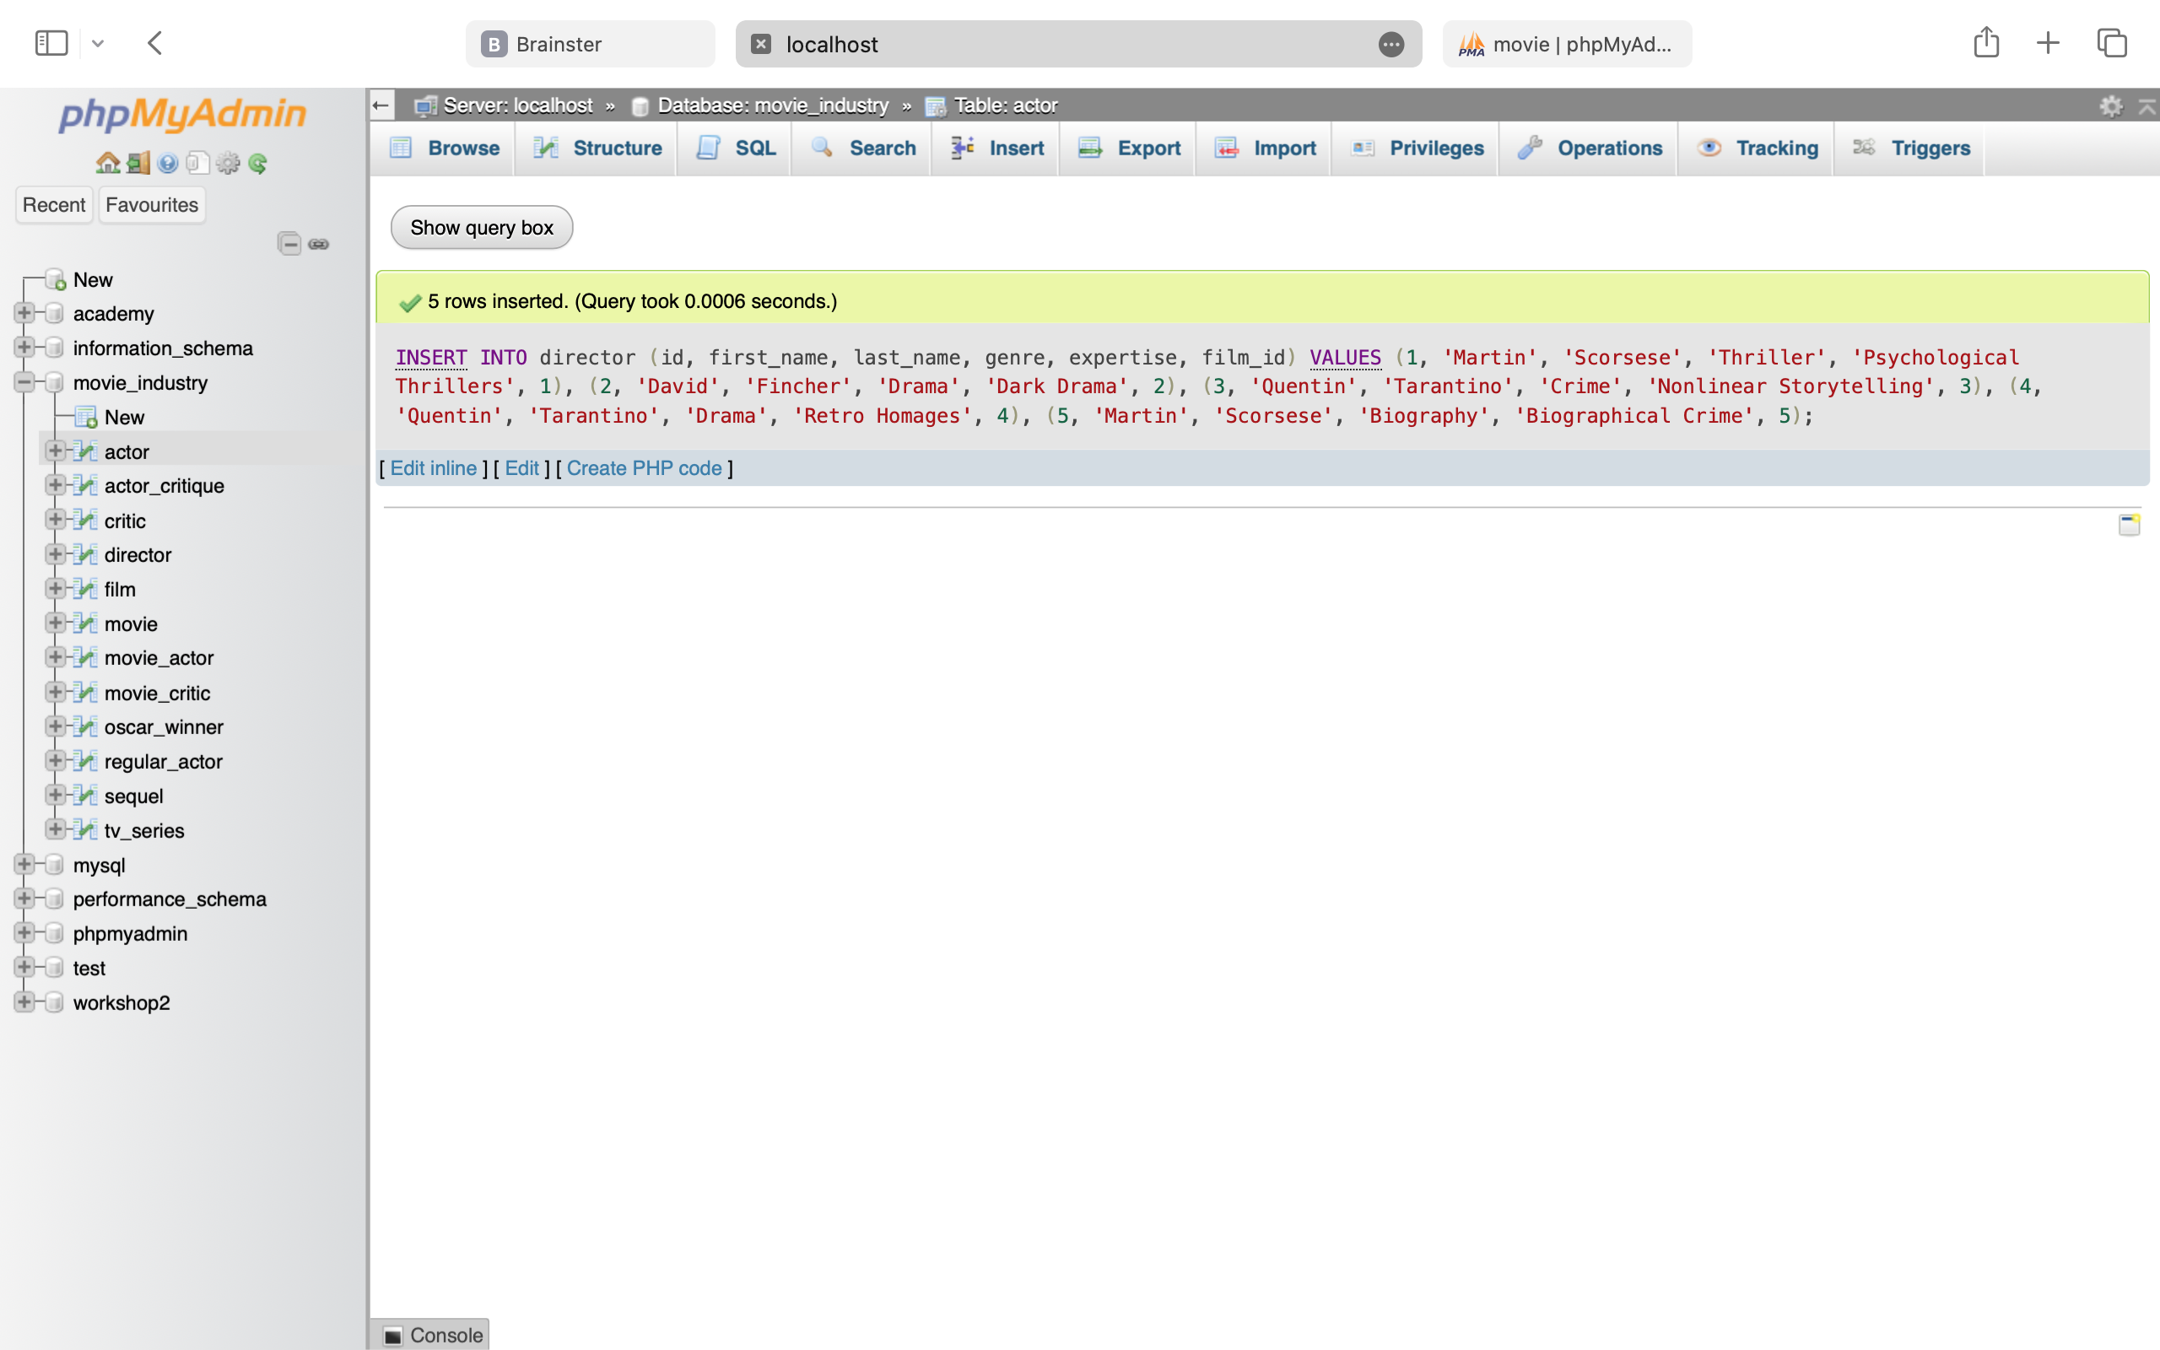

INSERT INTO movie_actor (movie_id, actor_id, payment)

VALUES

(1, 1, 20000000),

(2, 2, 17000000),

(3, 3, 15000000),

(4, 2, 25000000),

(5, 1, 25000000)



INSERT INTO critic (id, first_name, last_name, username, password)

VALUES

(1, 'Tina', 'Djurkovic', 'kidrauhl23', 'password1'),

(2, 'Borjan', 'Strashevski', 'trentalexandararnold', 'password2'),

(3, 'Stela', 'Jovanoska', 'stelaxo', 'password3'),

(4, 'Ana', 'Aleksoska', 'ninjashoyo', 'password4'),

(5, 'Marijan', 'Djurkovic', 'orion23', 'password5')

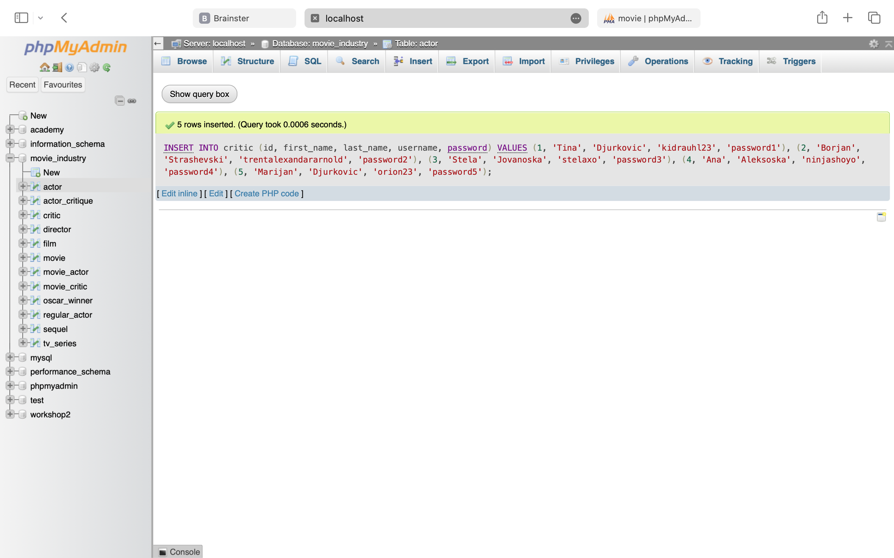

INSERT INTO movie_critic (movie_id, critic_id, rating)

VALUES

(1, 5, 4.5),

(2, 4, 4.7),

(3, 3, 4.9),

(4, 2, 4.3),

(5, 1, 4.8)

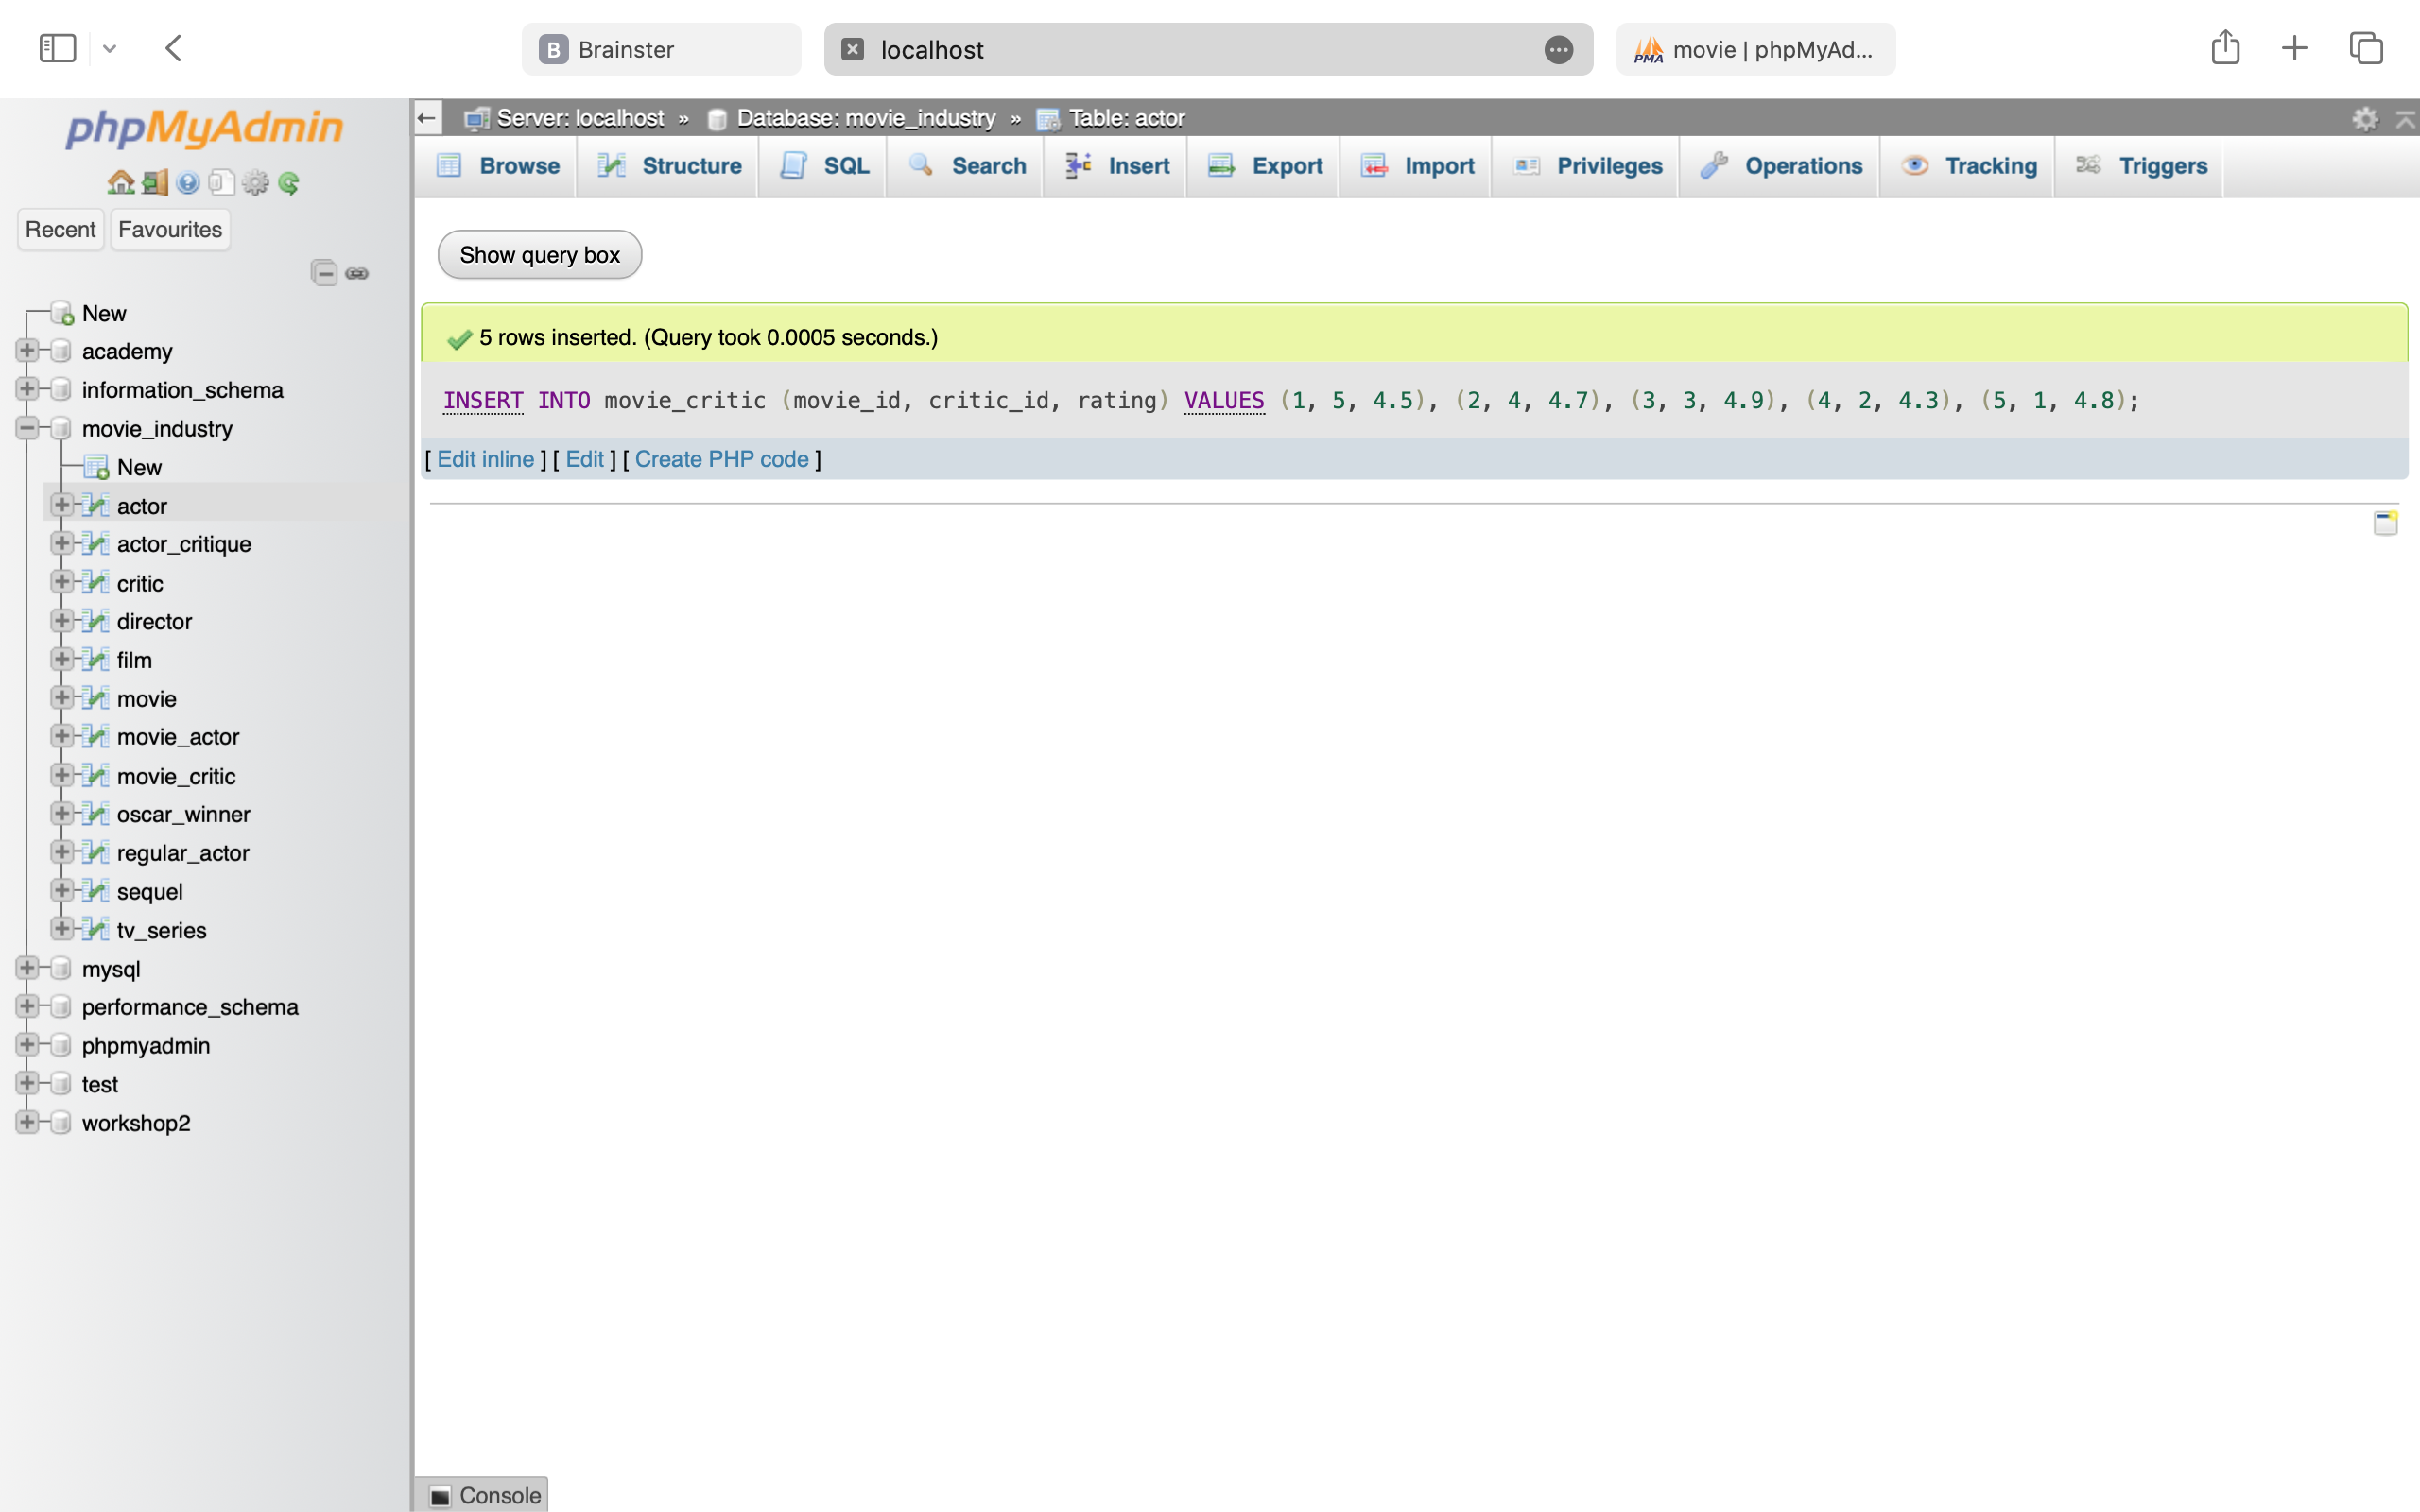

INSERT INTO actor_critique (movie_id, critic_id, actor_id, acting_grade, expression_grade, naturalness_grade, devotion_grade)

VALUES

(1, 1, 1, 4.8, 4.9, 4.7, 4.9),

(2, 2, 2, 4.6, 4.8, 4.5, 4.7),

(3, 3, 3, 4.9, 4.9, 4.8, 4.9),

(4, 4, 2, 4.7, 4.6, 4.8, 4.7),

(5, 5, 1, 4.8, 4.7, 4.7, 4.9)

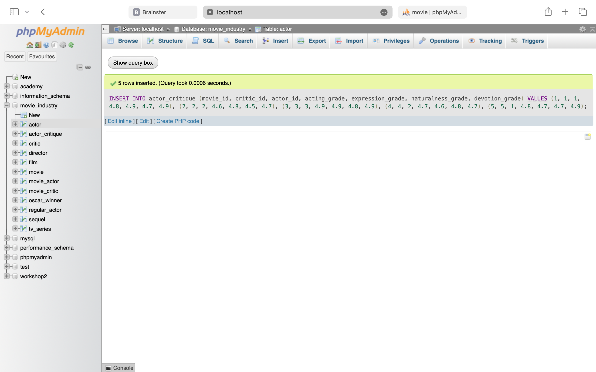

**1. List all information from each table separately:**

SELECT * FROM actor;

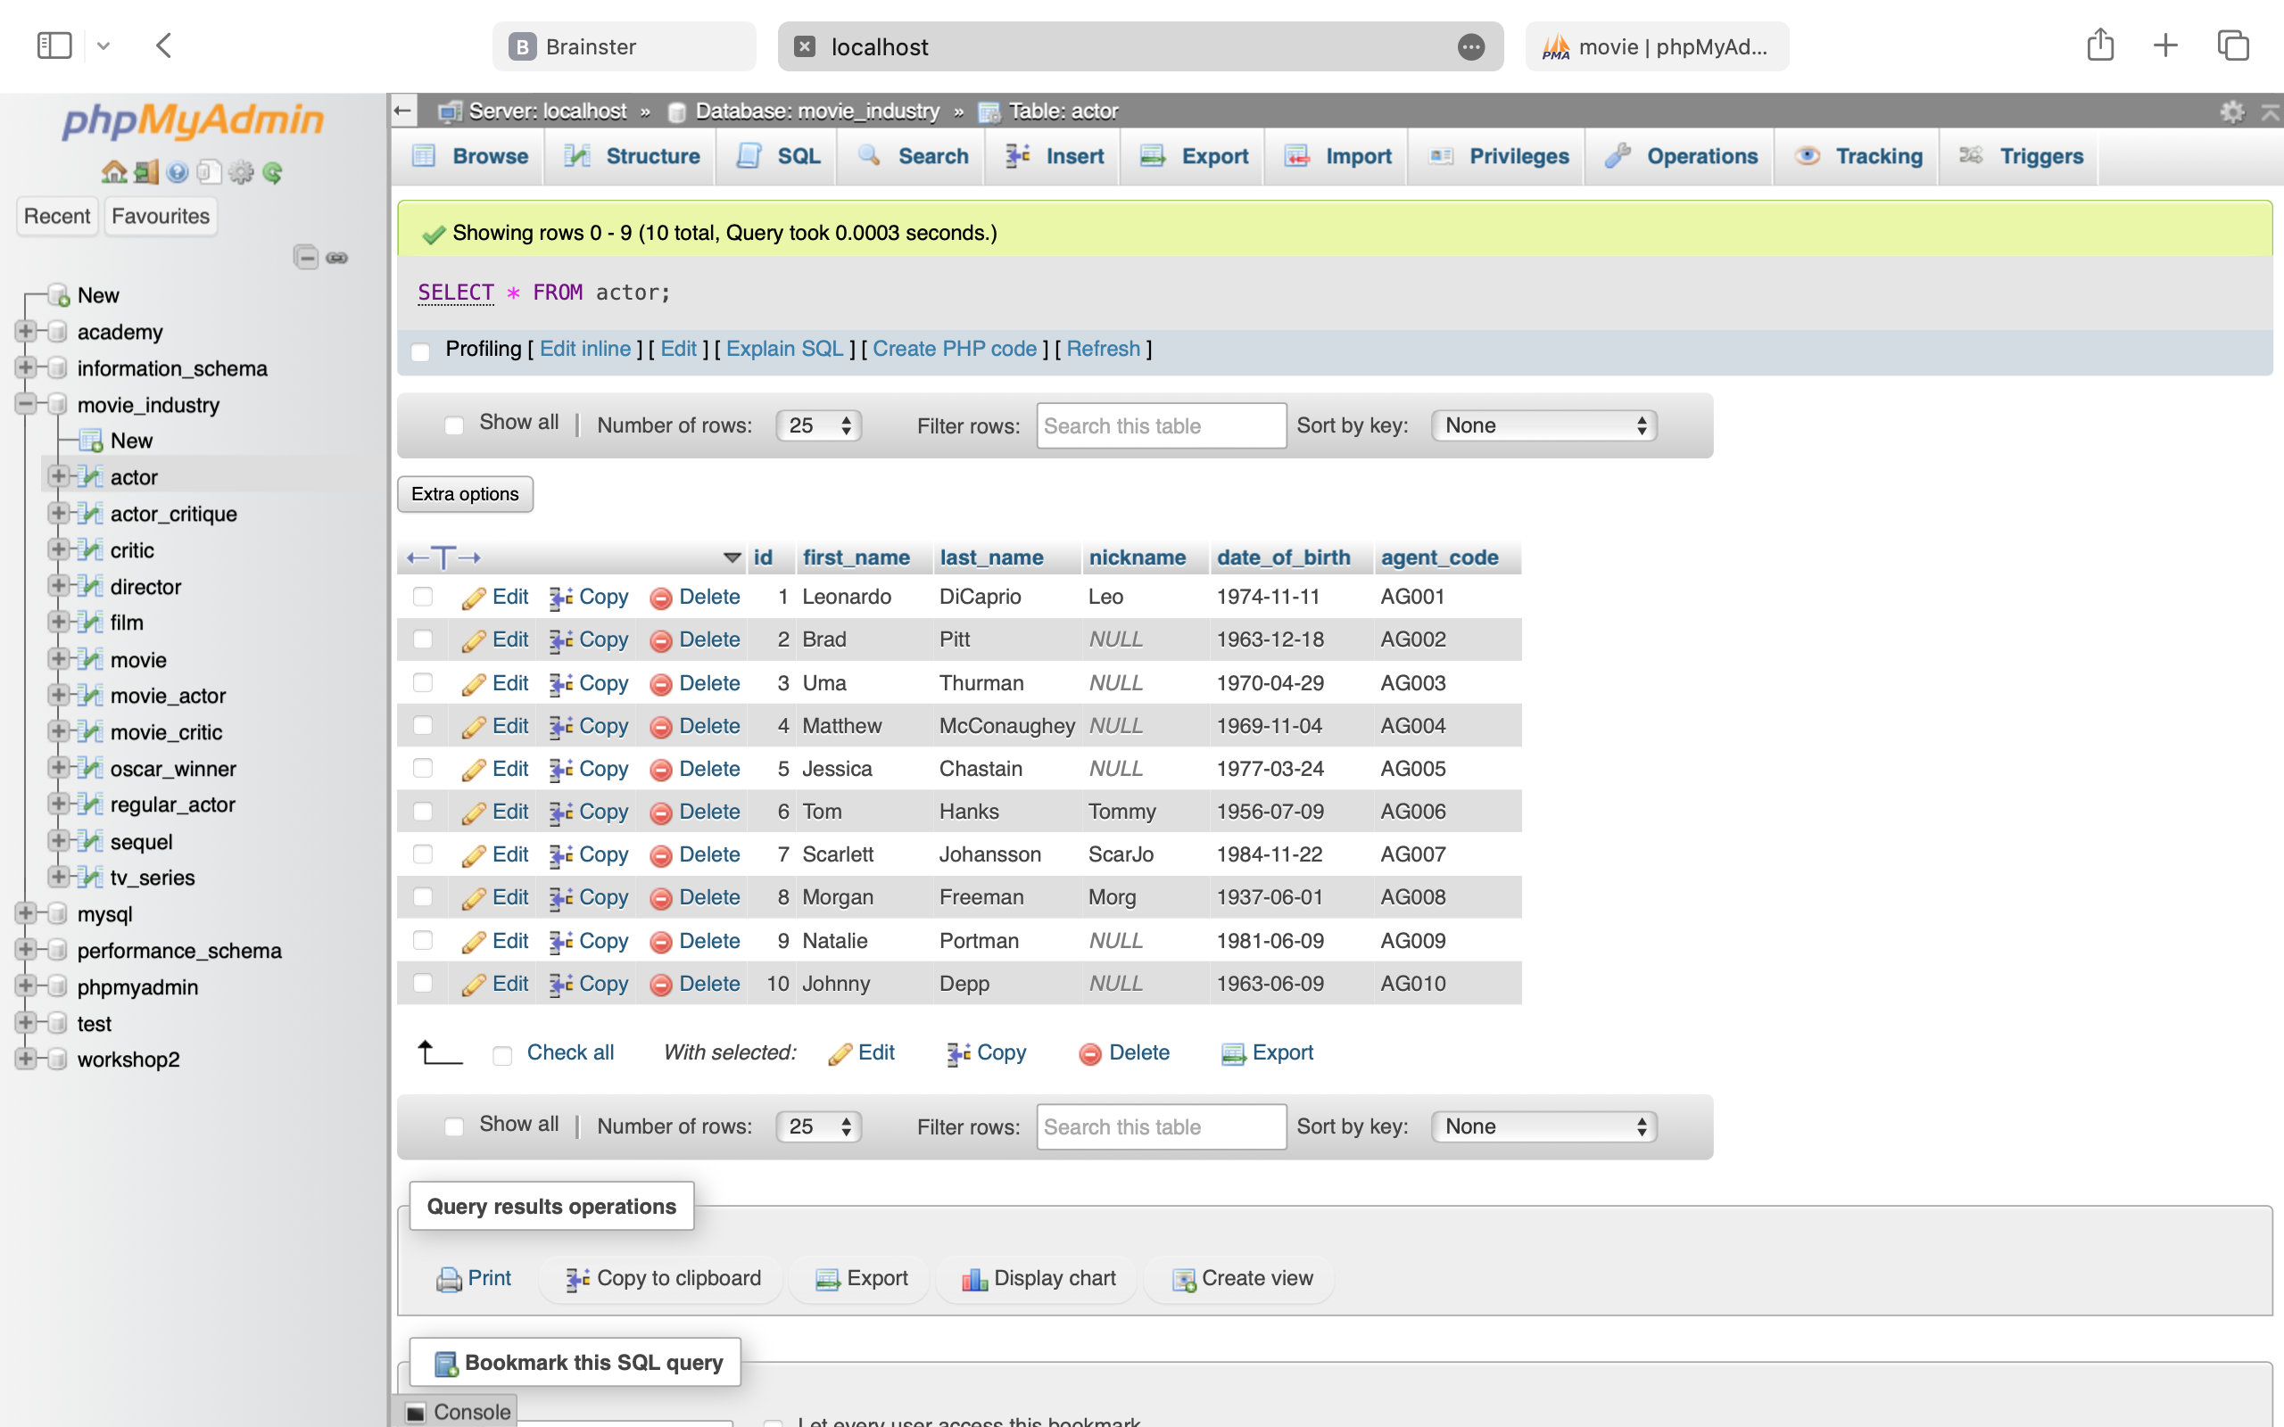

SELECT * FROM actor_critique;

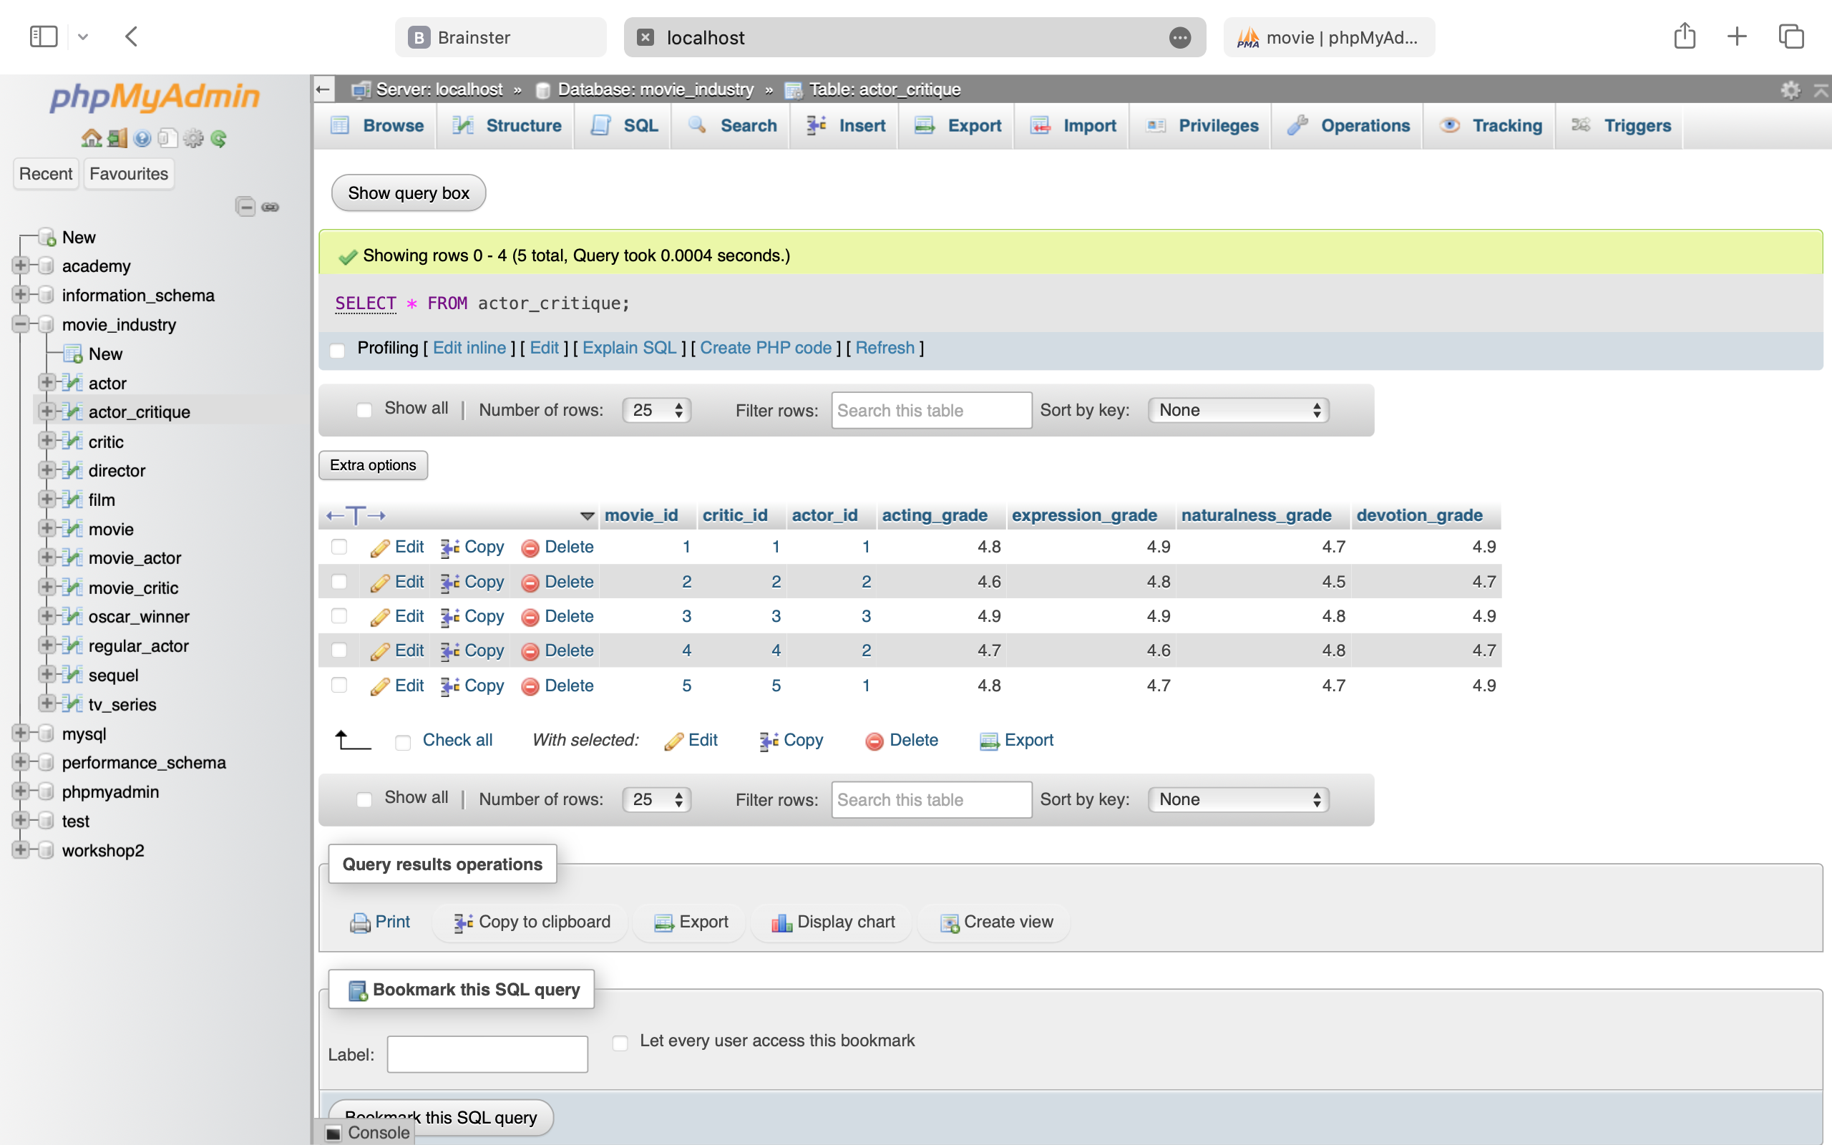

SELECT * FROM critic;



SELECT * FROM director;



SELECT * FROM film;

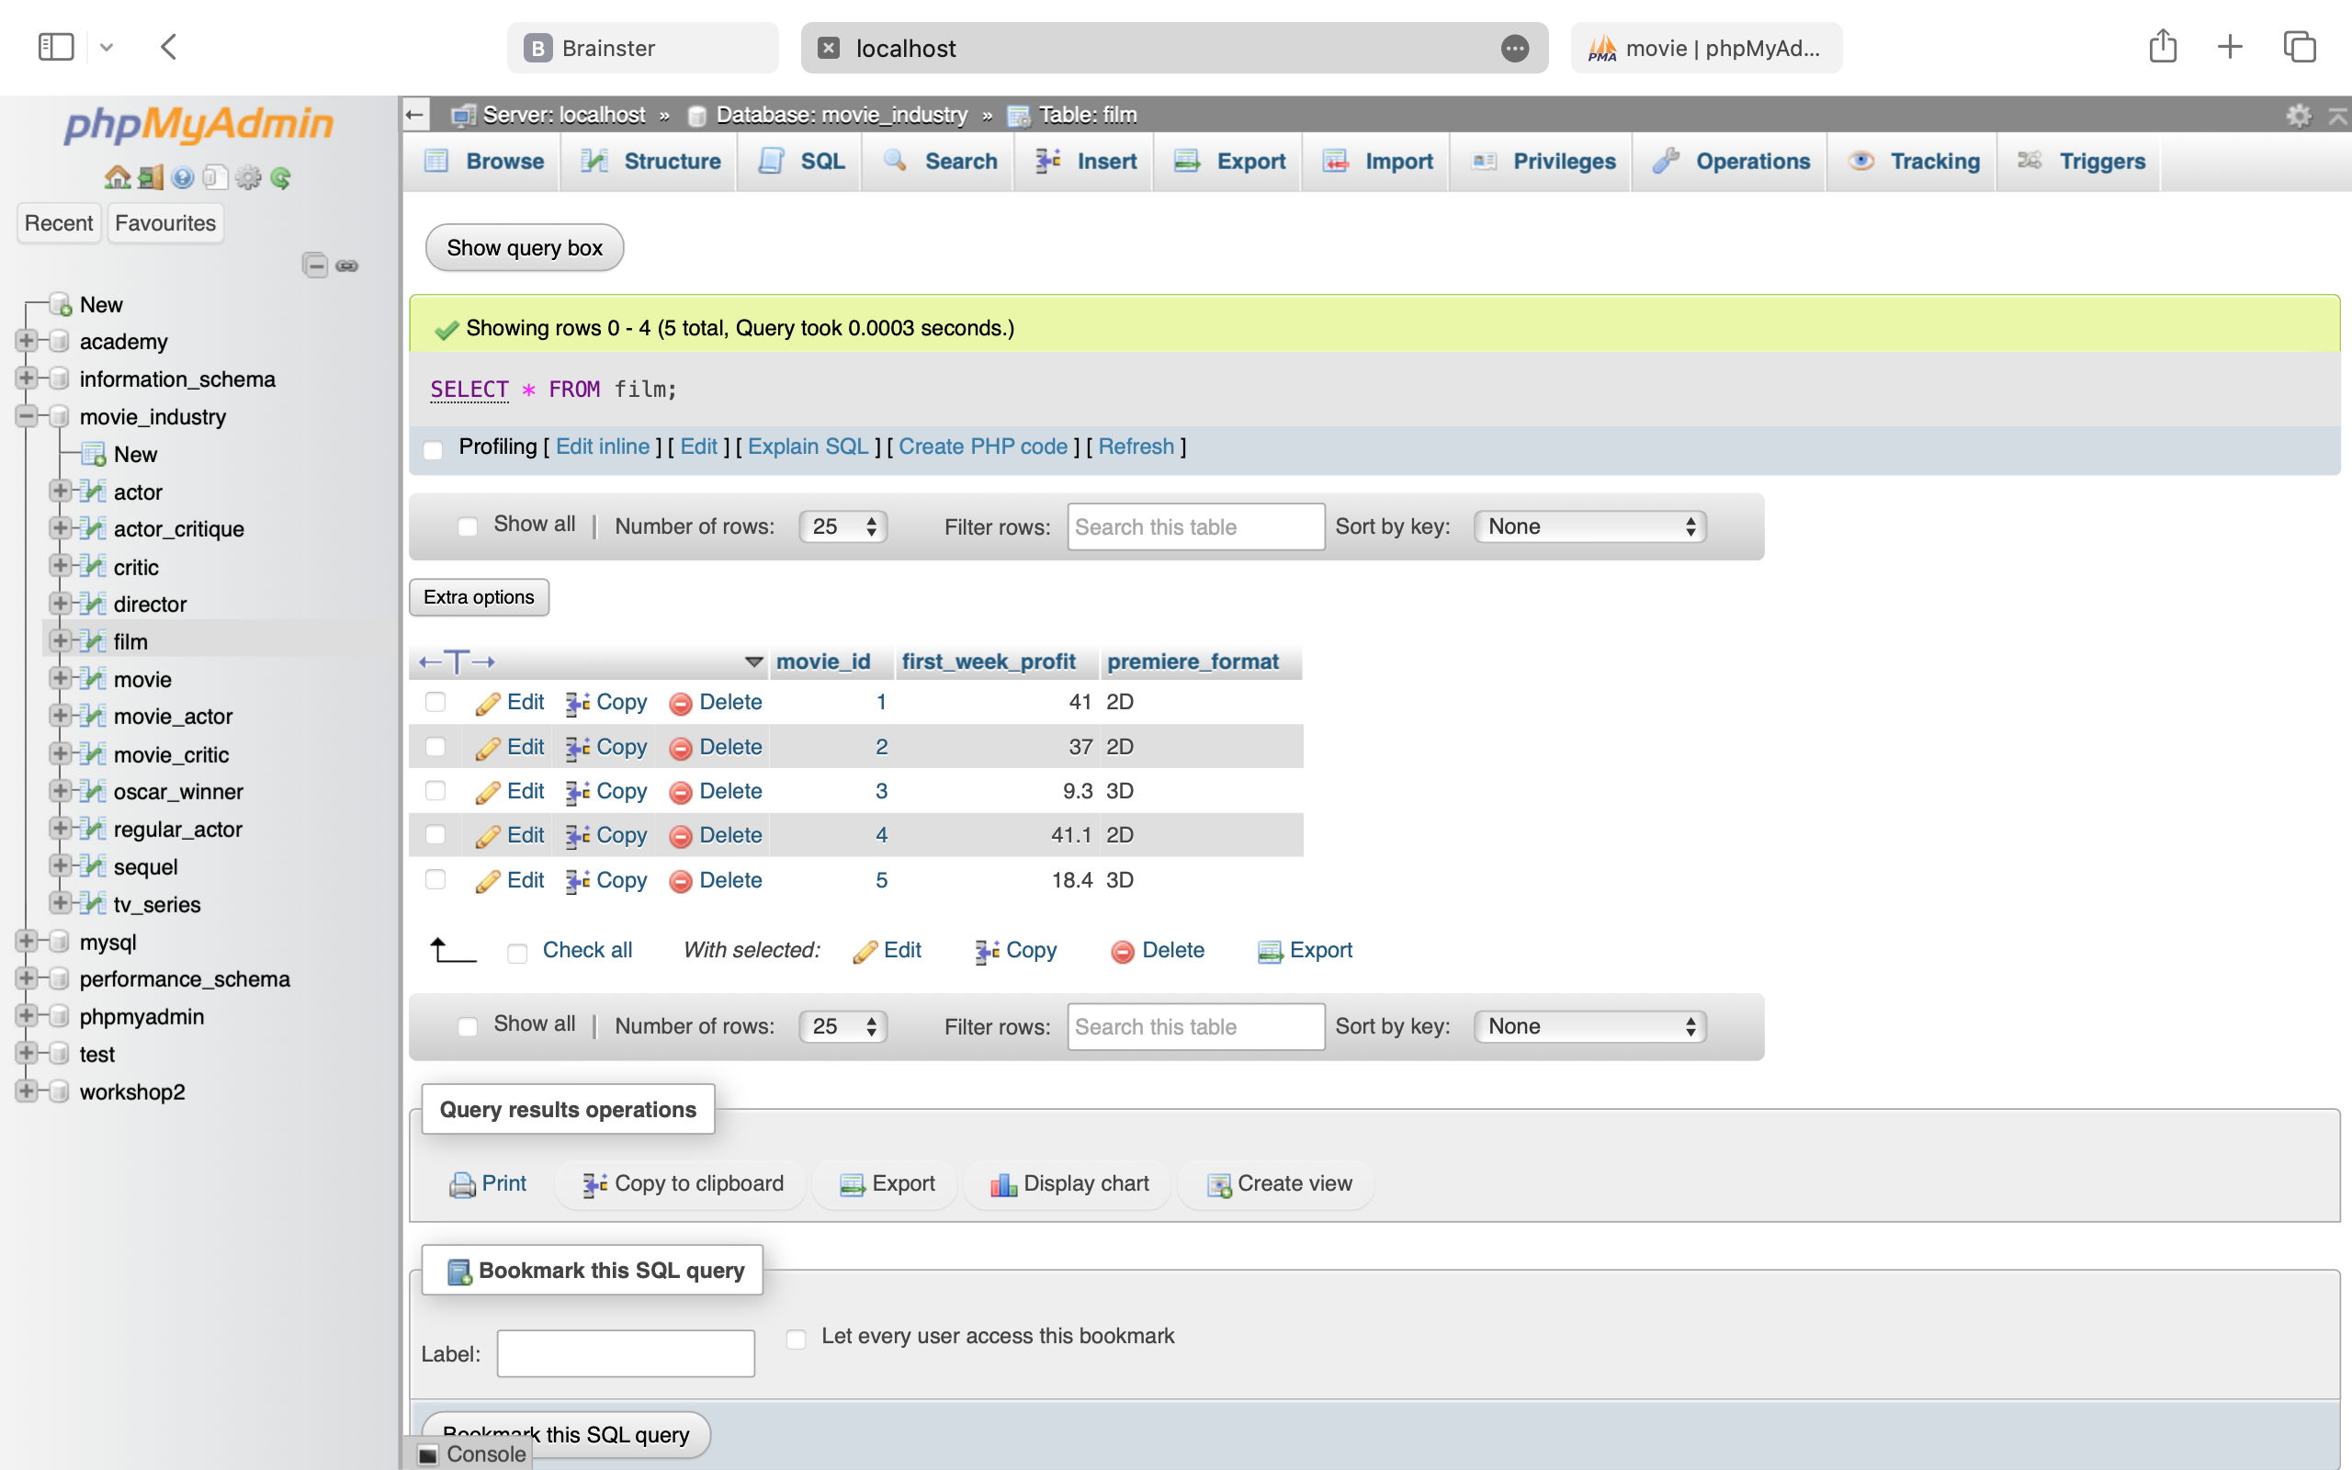

SELECT * FROM movie;

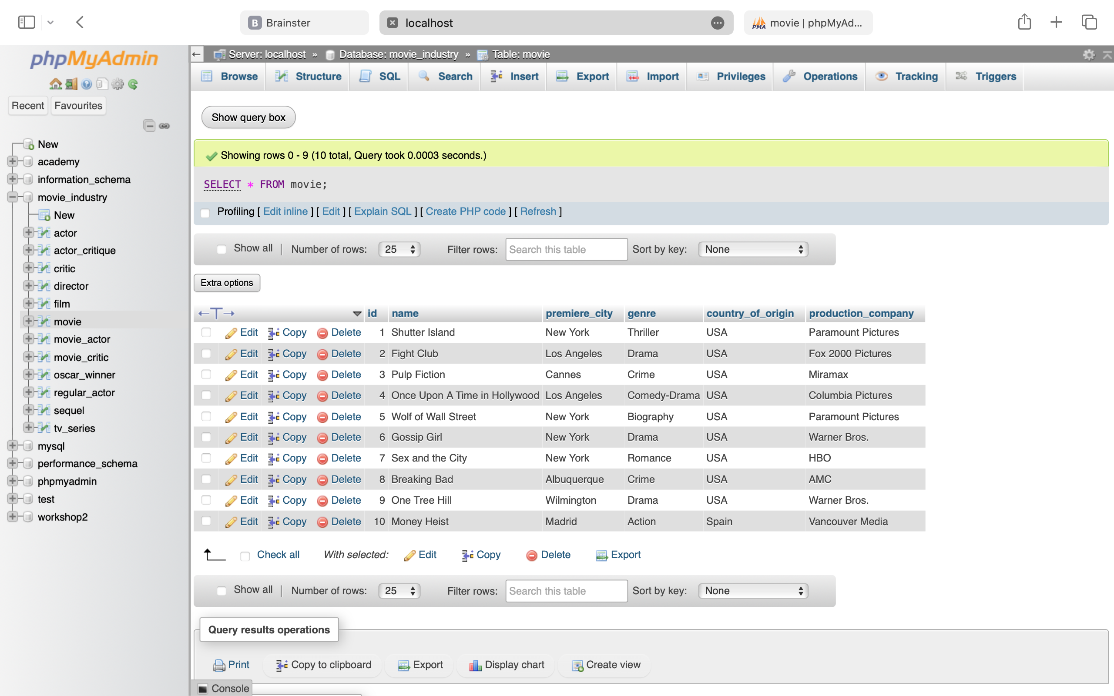

SELECT * FROM movie_actor;

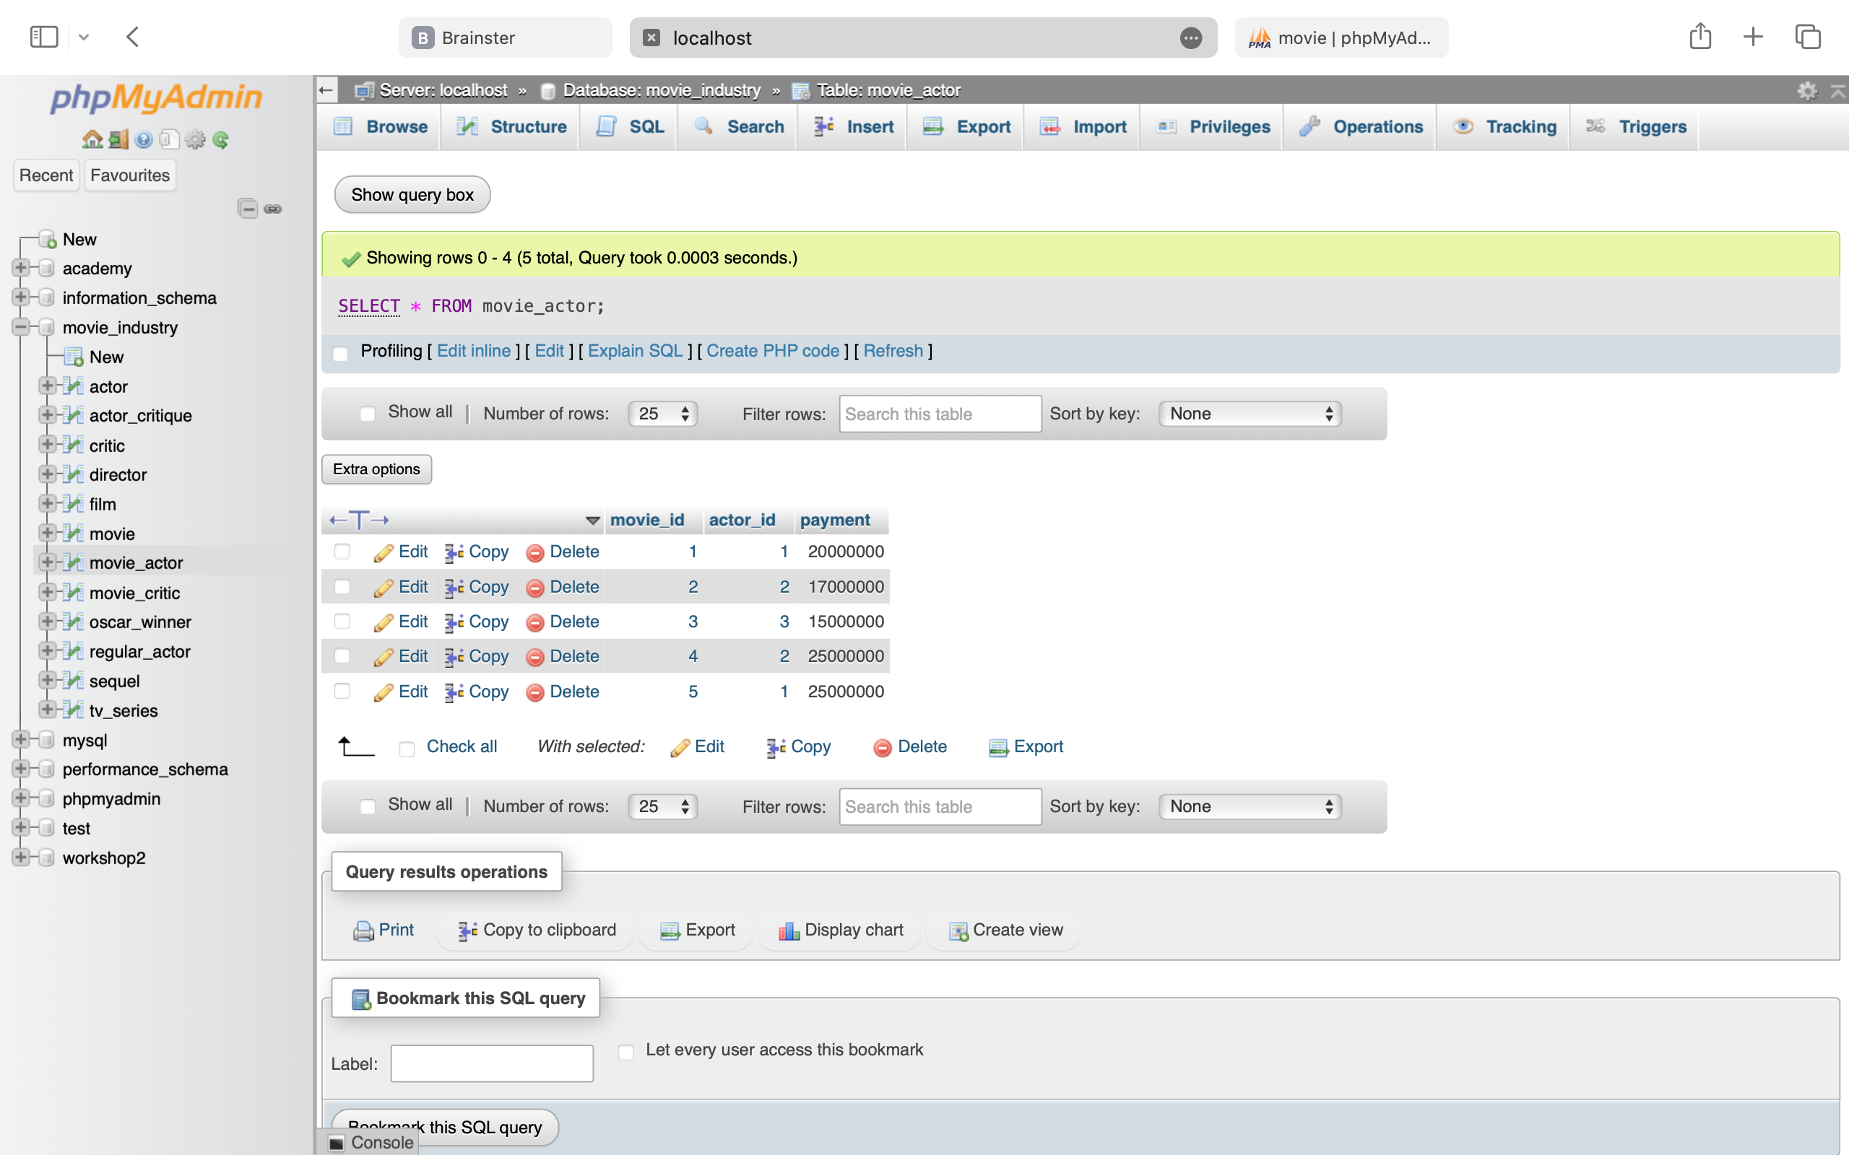

SELECT * FROM movie_critic;

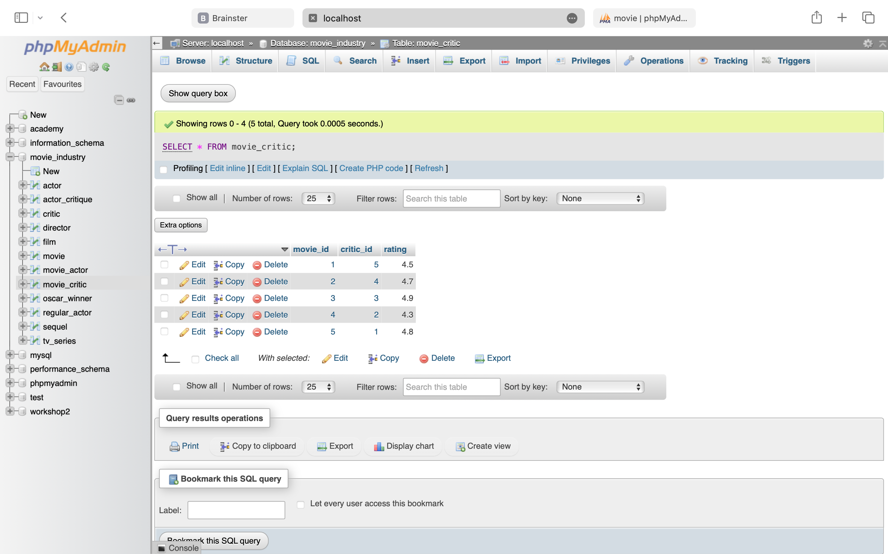

SELECT * FROM oscar_winner;



SELECT * FROM regular_actor;



SELECT * FROM sequel;



SELECT * FROM tv_series;

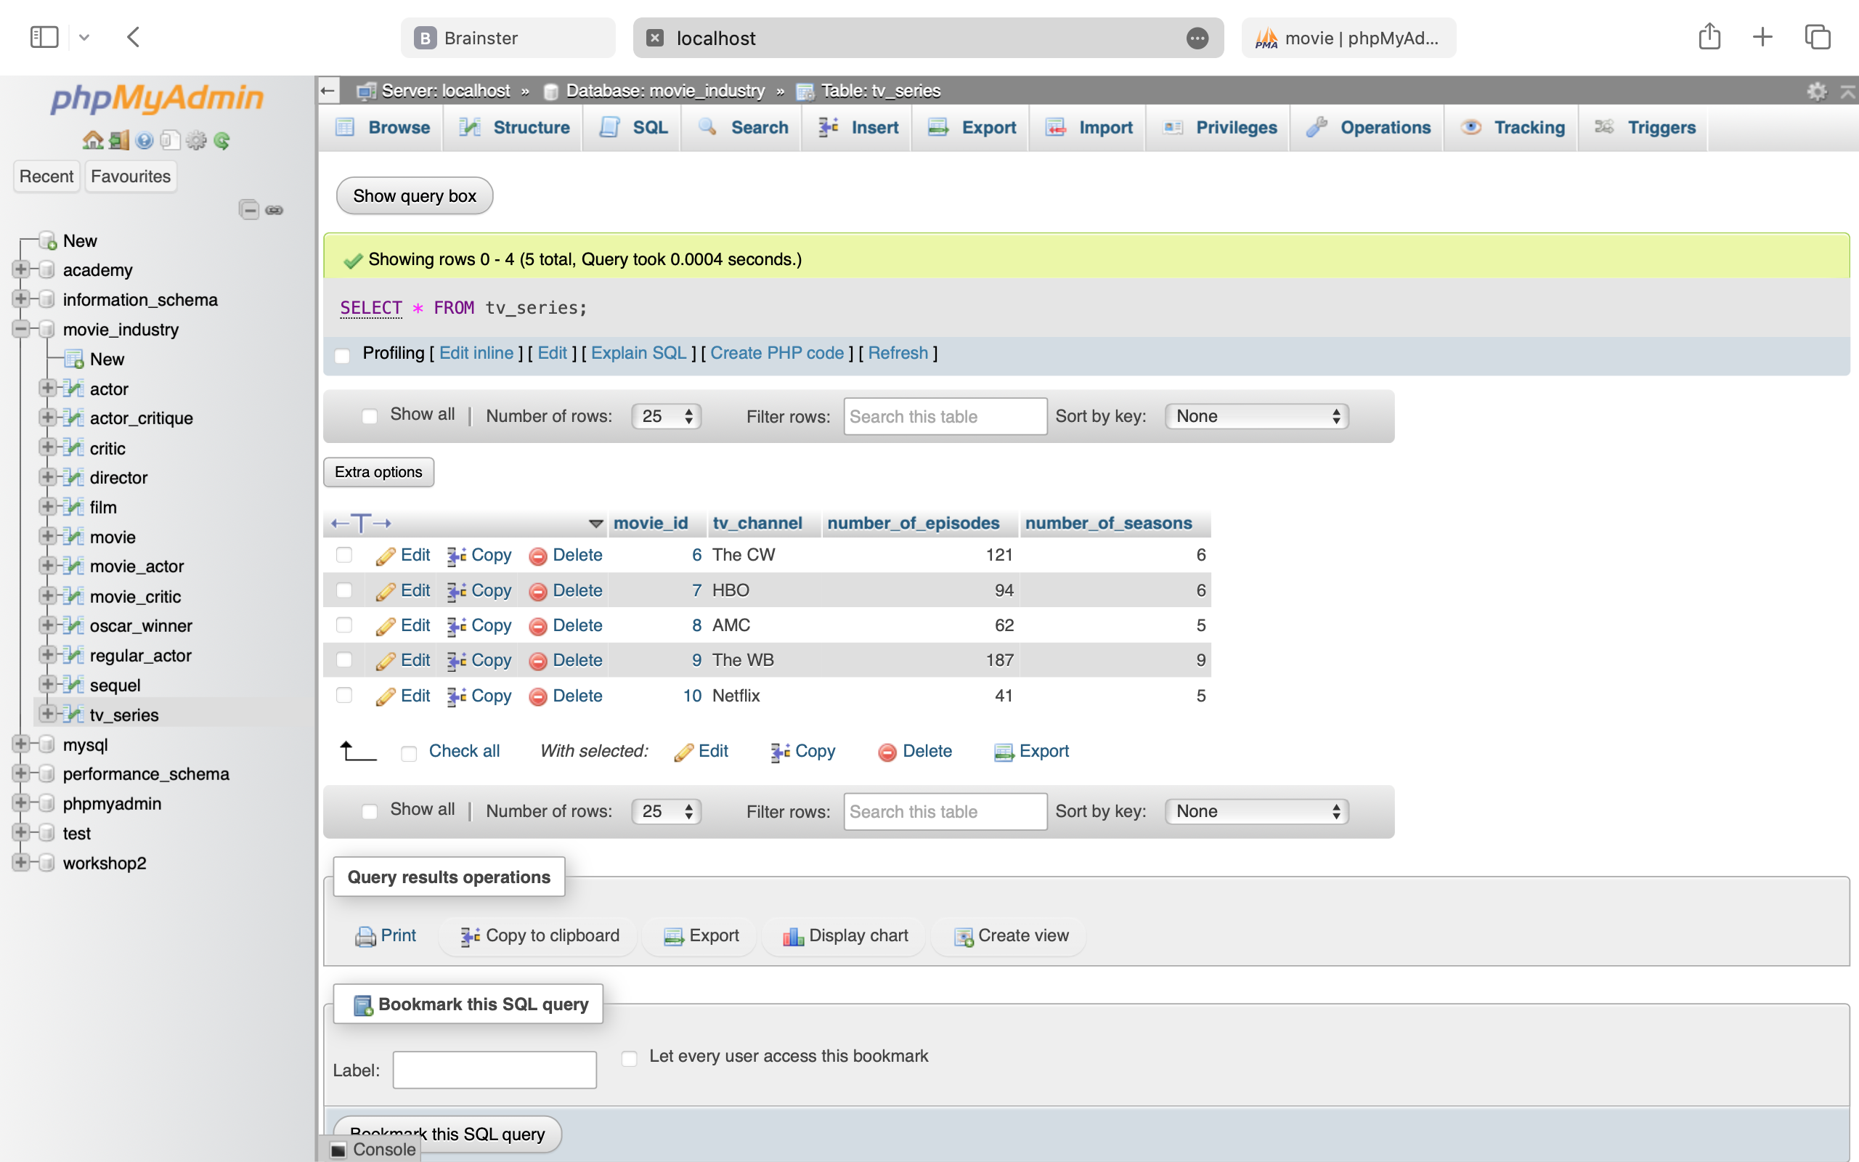

**2. List information about the movies (name of movie, premiere date, genre, country of origin, production, number of actors)**

SELECT name AS movie_name, premiere_city, genre, country_of_origin, production_company,

COUNT(actor_id) AS number_of_actors

FROM movie

LEFT JOIN movie_actor ON id = movie_id

GROUP BY id

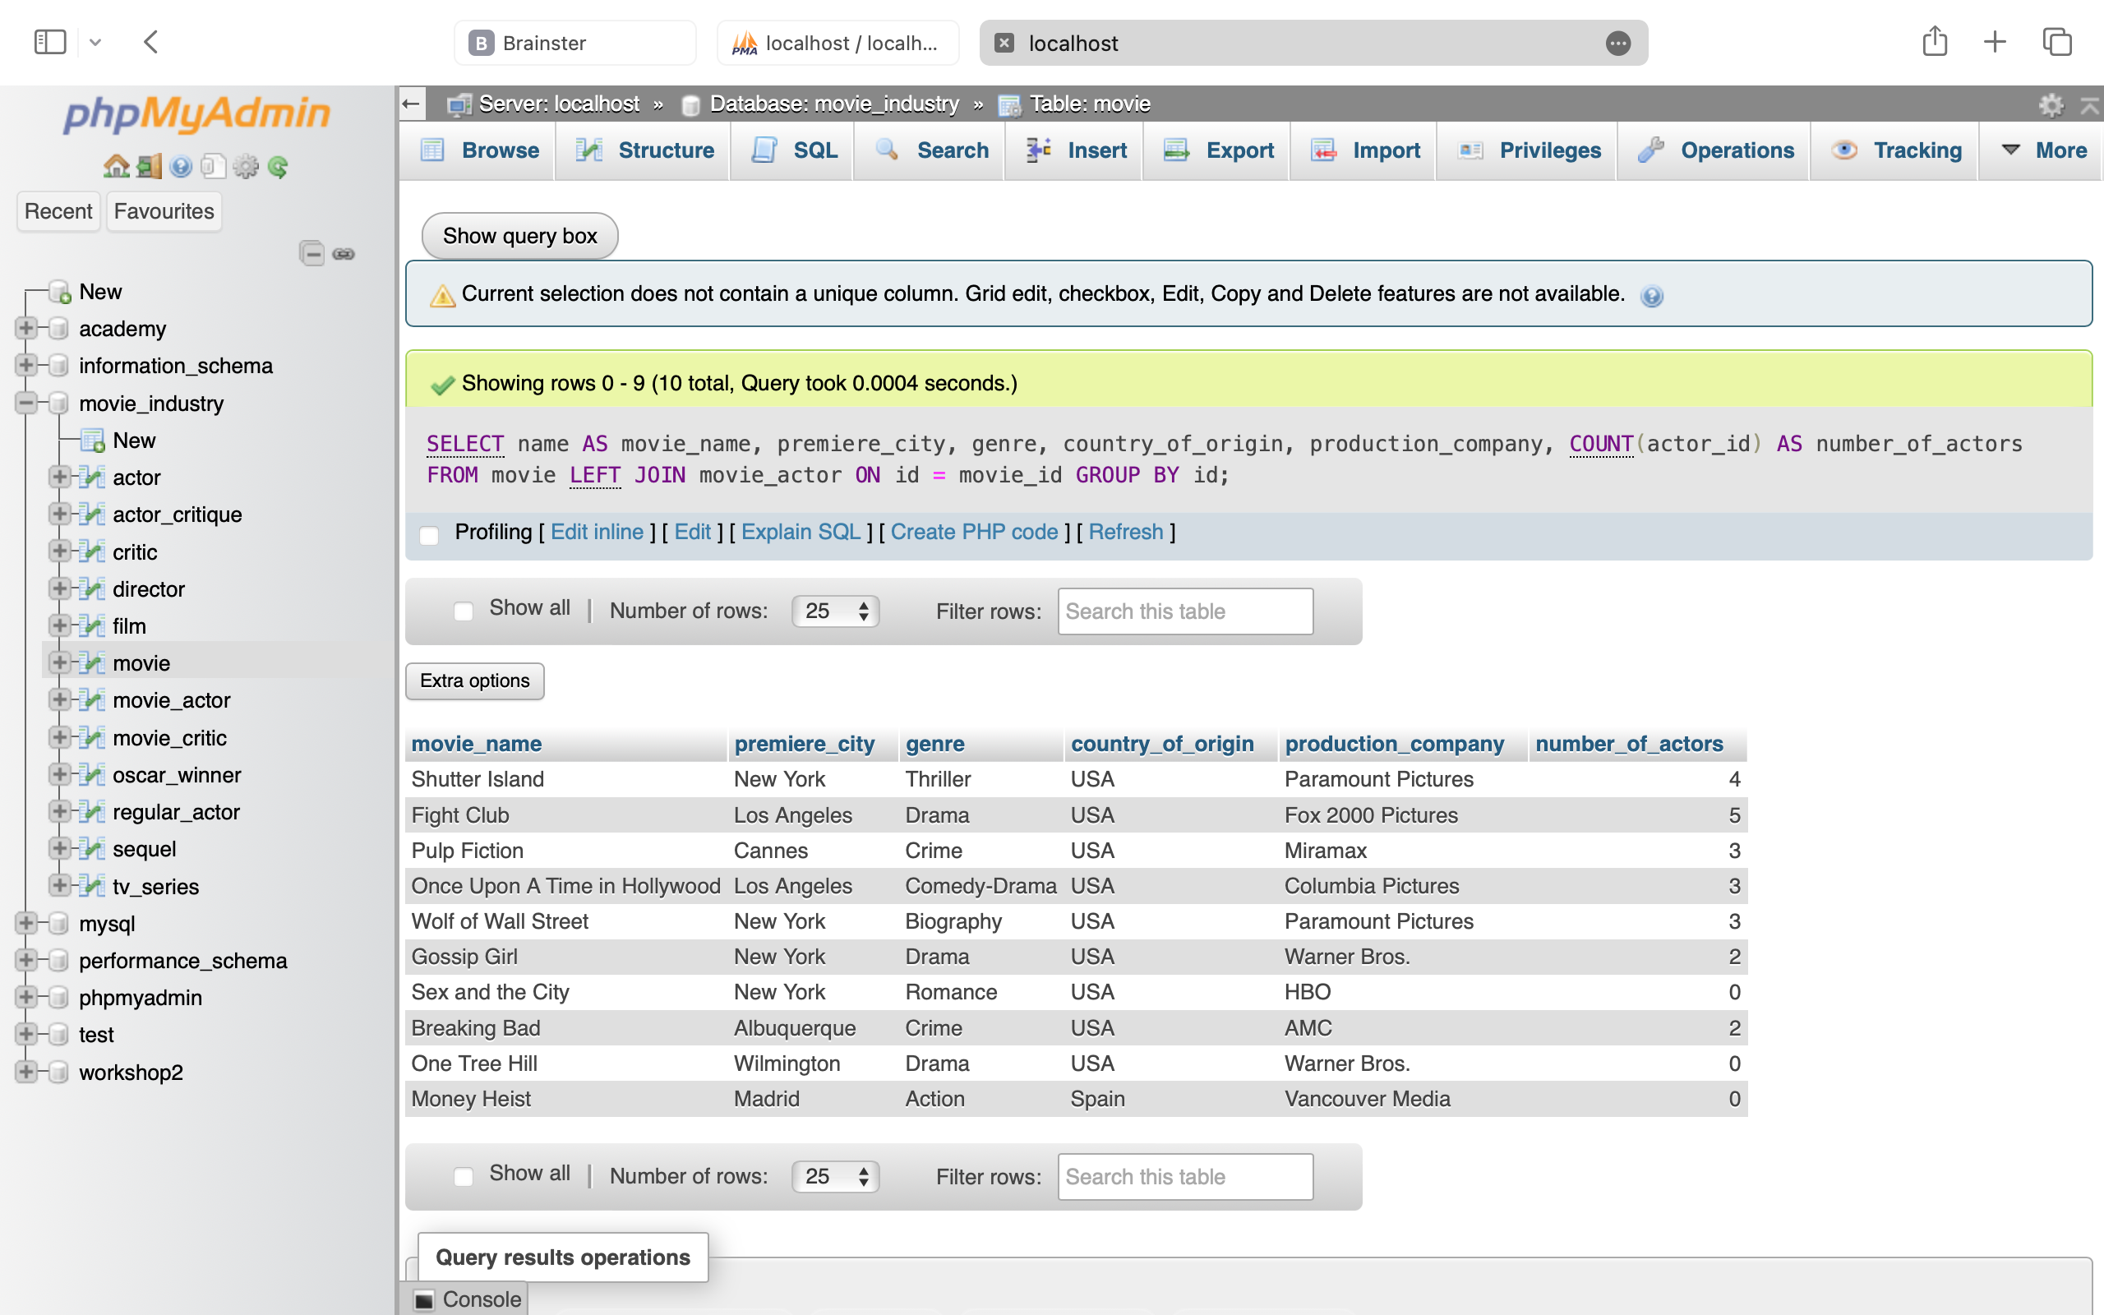

**3. List all information for the actors (first name, last name, nickname, date of birth, agent code and number of movies in which have acted)**

SELECT first_name, last_name, nickname, date_of_birth, agent_code, COUNT(movie_id) AS number_of_movies

FROM actor

JOIN movie_actor ON id = actor_id

GROUP BY id

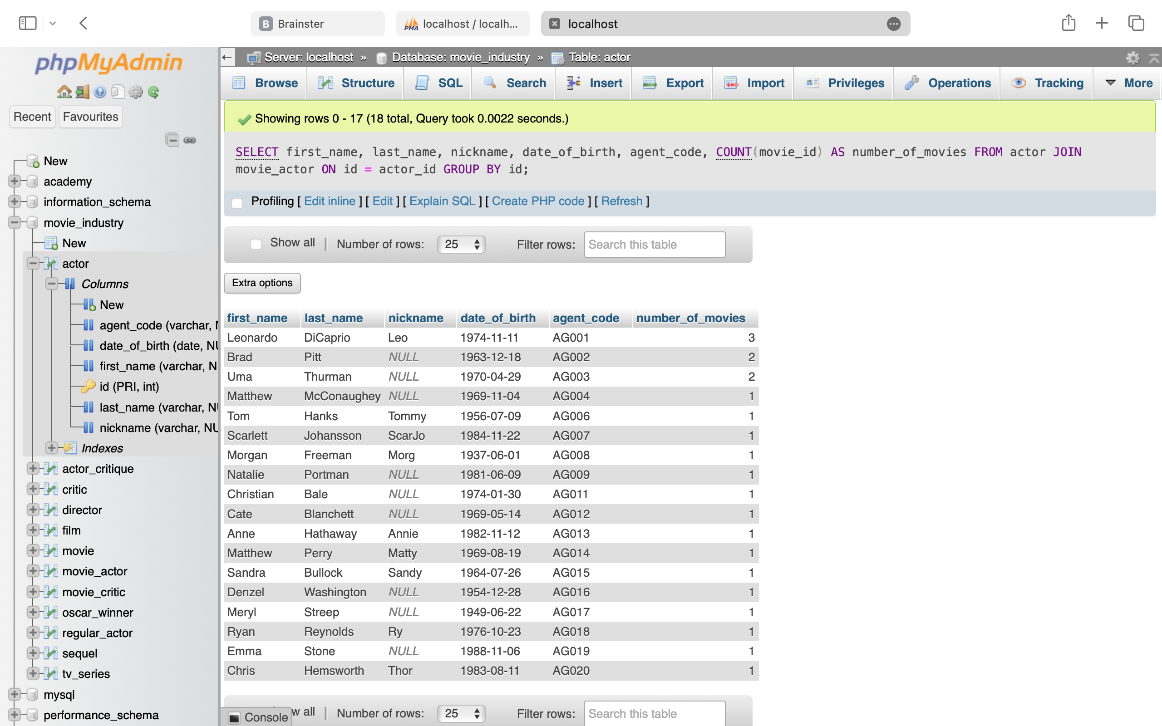

**4. List all movies with their information (premiere city, how much money they have made during the first week of premiere, and premiere format (2D - 3D), ordered by premiere format)**

SELECT name, premiere_city, first_week_profit, premiere_format FROM movie

JOIN film ON id = movie_id

ORDER BY premiere_format

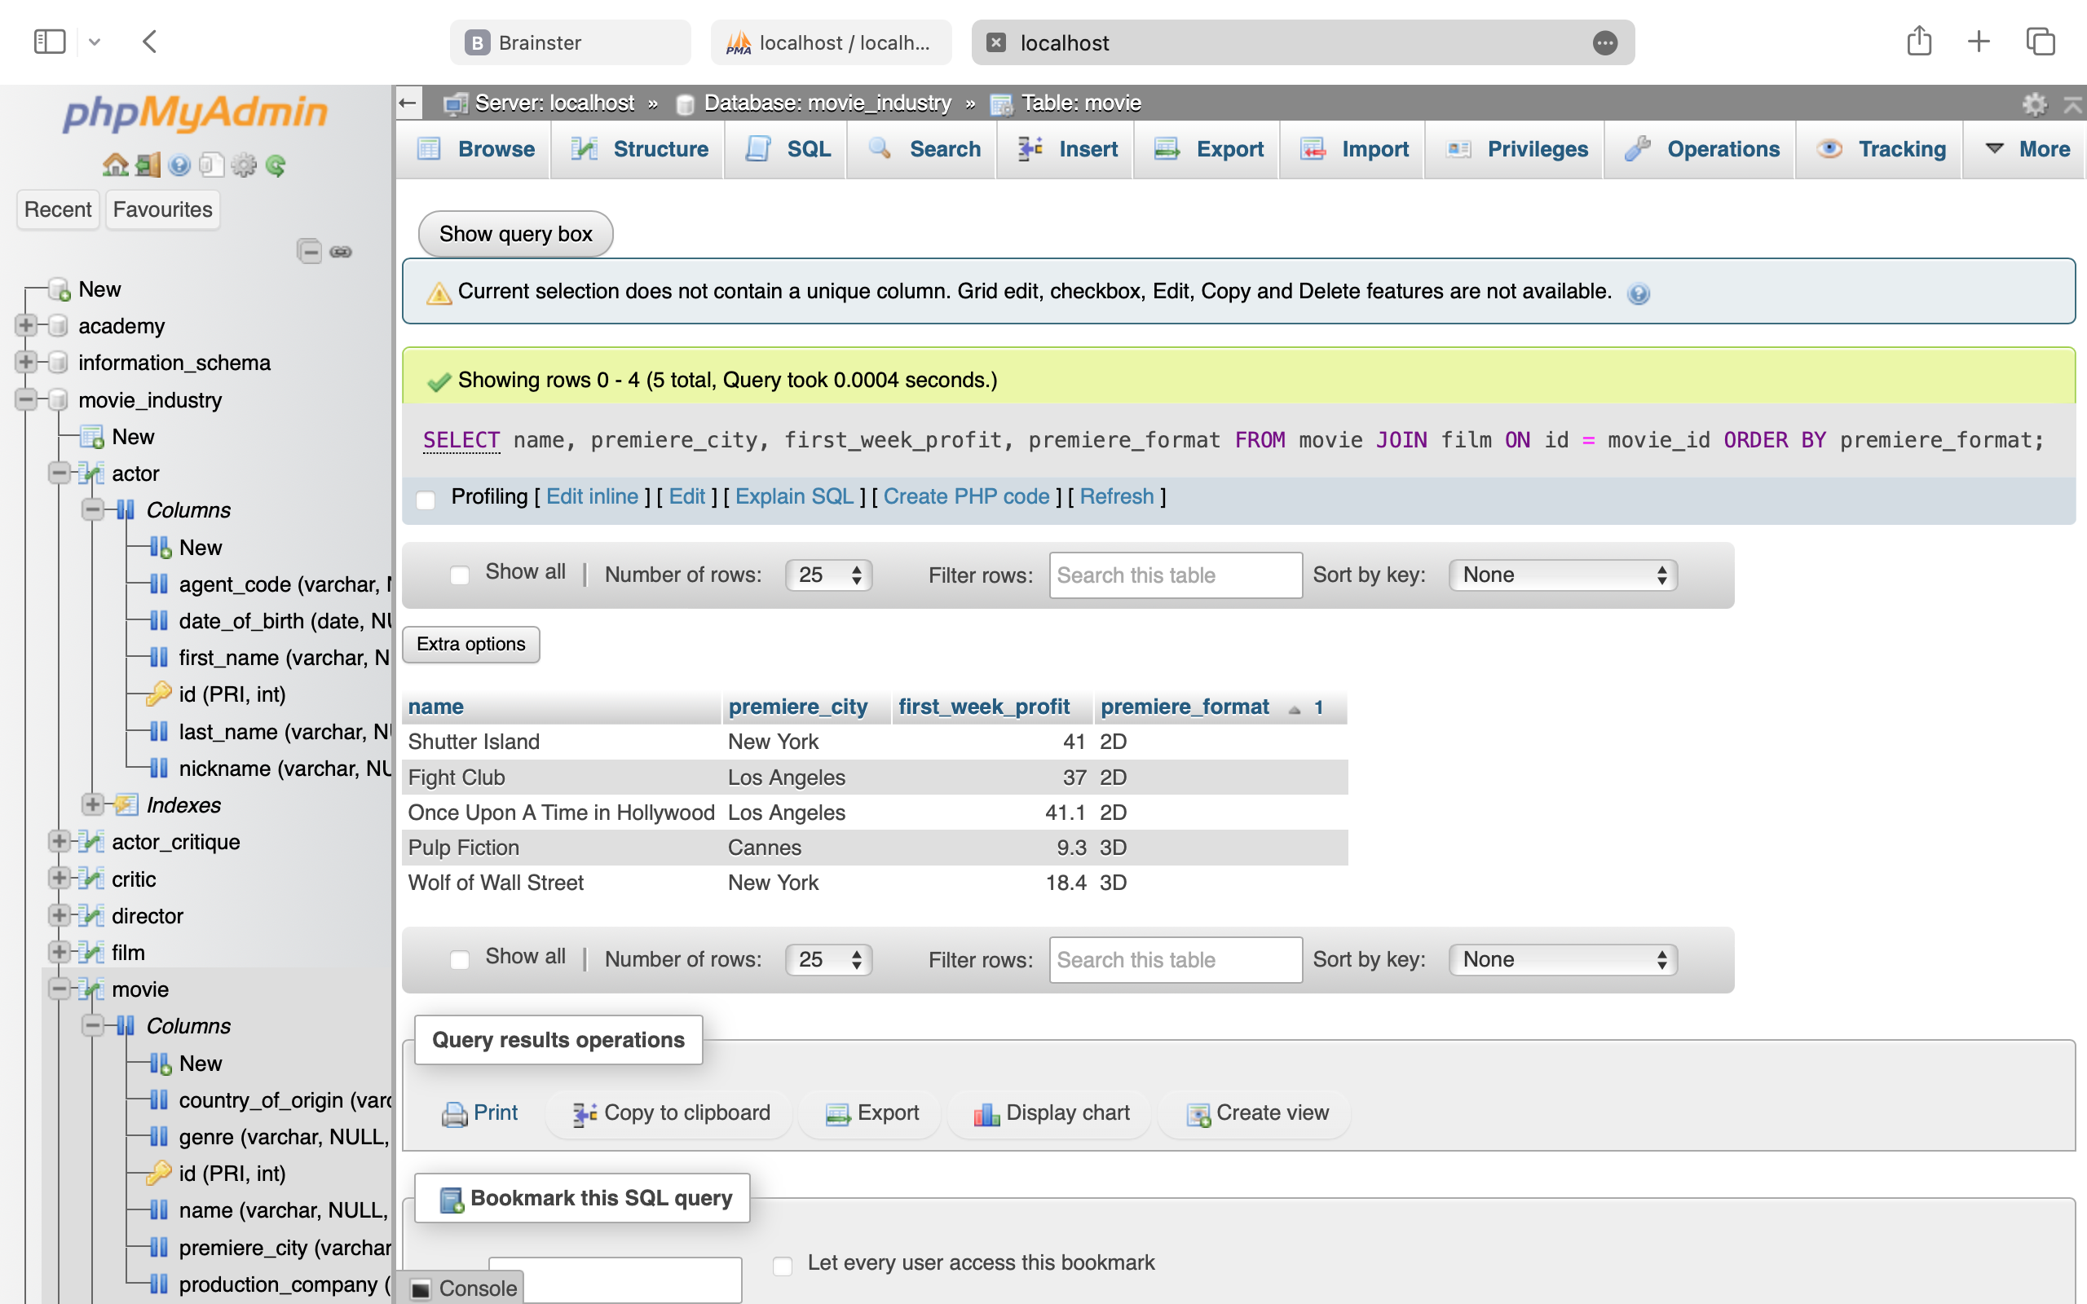

**5. List all information about the Oscar winners (for which movie they have won an Oscar, for which role in that movie and in which year, as well as the first name of the actor, last name, nickname, date of birth and agent code). List all this information sorted by the year in which they have won the Oscar, so that the newest will be first**

SELECT movie.name AS movie_name, oscar_winner.role, oscar_winner.year, actor.first_name, actor.last_name, actor.nickname, actor.date_of_birth, actor.agent_code

FROM oscar_winner

JOIN movie ON movie.id = oscar_winner.movie_id

JOIN actor ON actor.id = oscar_winner.actor_id

ORDER BY year DESC

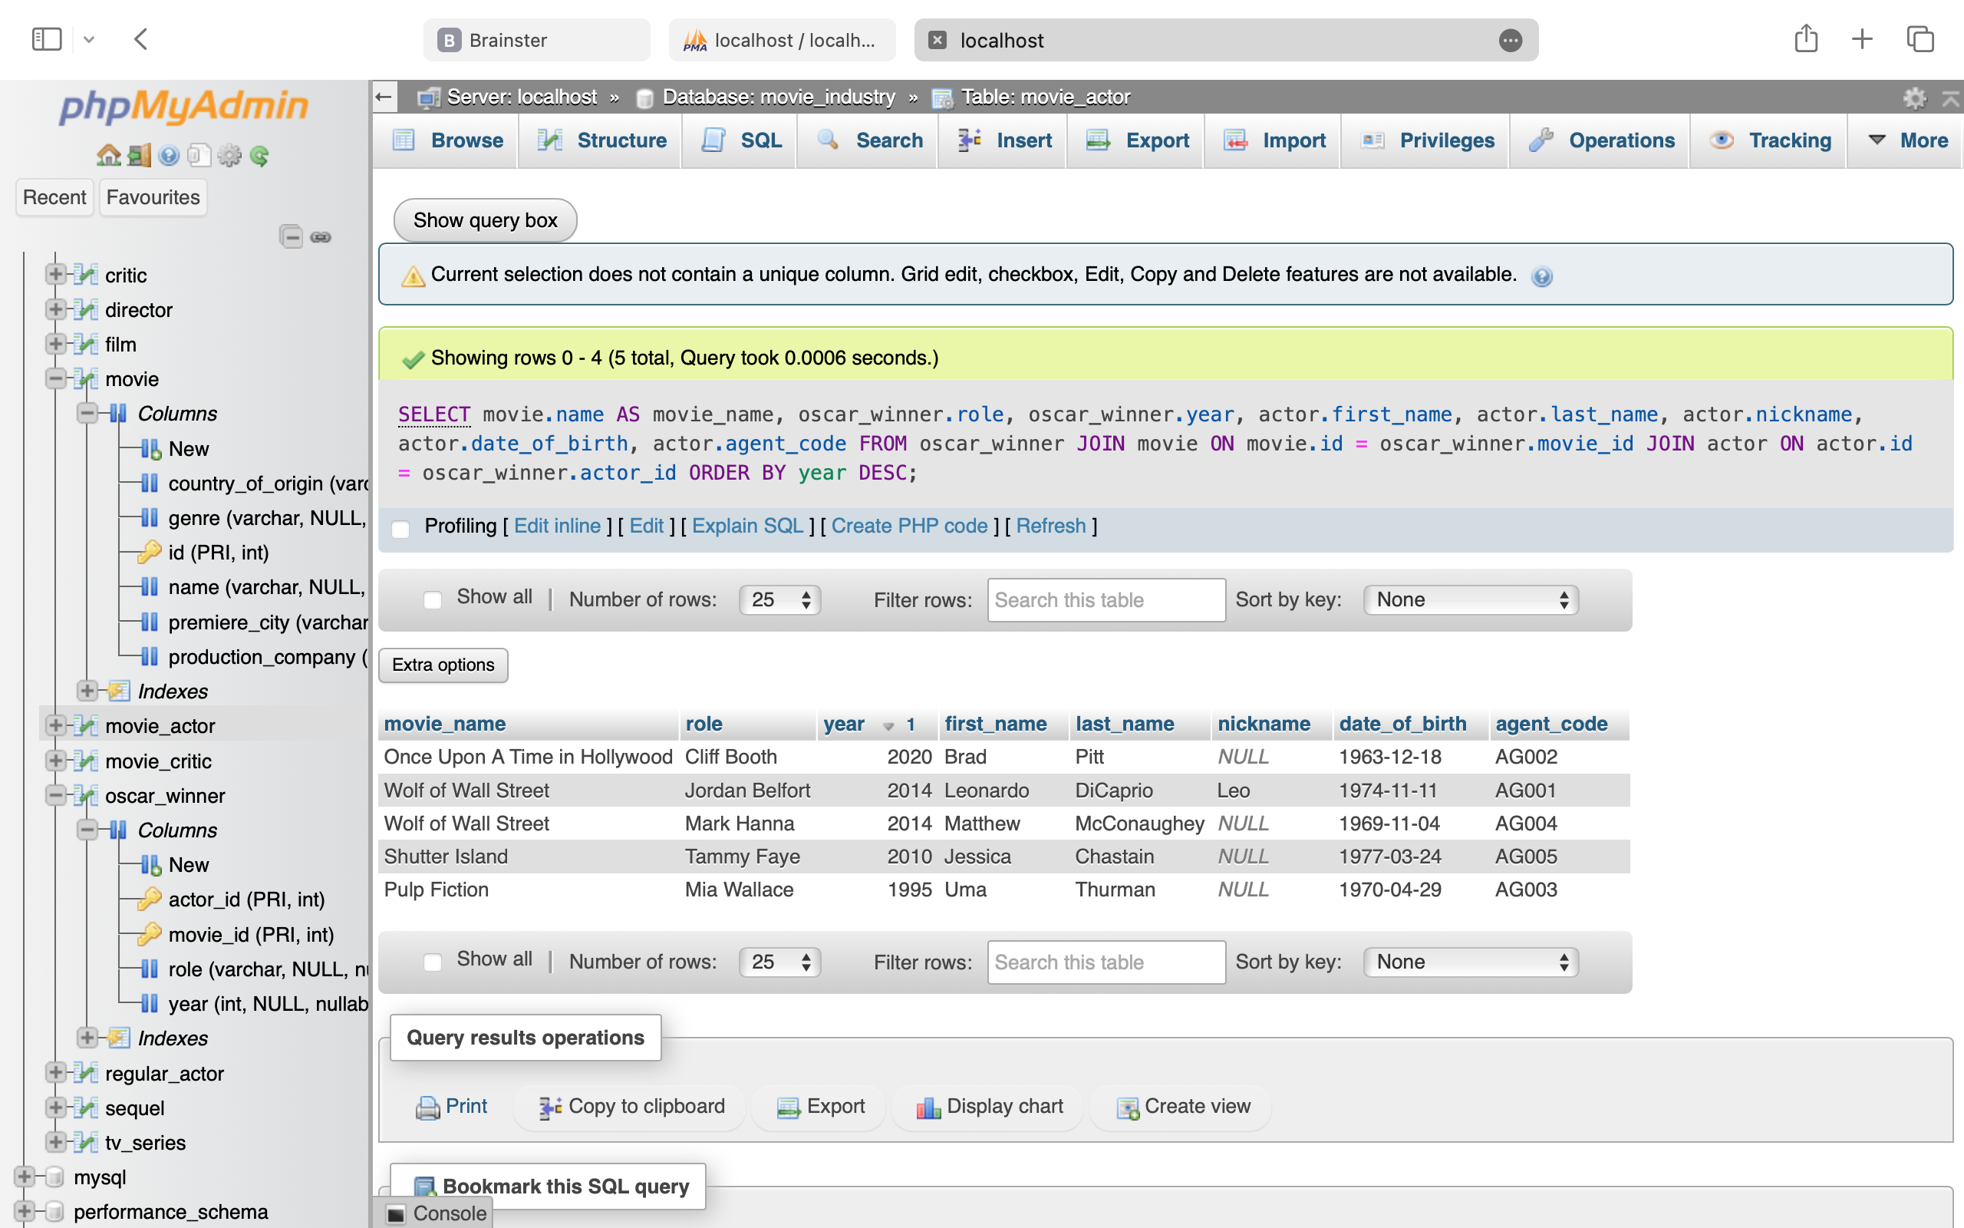

**6. List all information about the films, along with the actors that have acted in them and the directors who have directed them, ordered by the directors’ names**

SELECT movie.name AS movie_name, film.premiere_format, film.first_week_profit,

GROUP_CONCAT(CONCAT(actor.first_name, ' ', actor.last_name) SEPARATOR ', ') AS actors,

CONCAT(director.first_name, ' ', director.last_name) AS director_fullname

FROM film

JOIN movie ON movie.id = film.movie_id

JOIN movie_actor ON movie_actor.movie_id = film.movie_id

JOIN actor ON actor.id = movie_actor.actor_id

JOIN director ON director.film_id = film.movie_id

GROUP BY movie.name, film.premiere_format, film.first_week_profit, director.first_name, director.last_name

ORDER BY director.first_name;

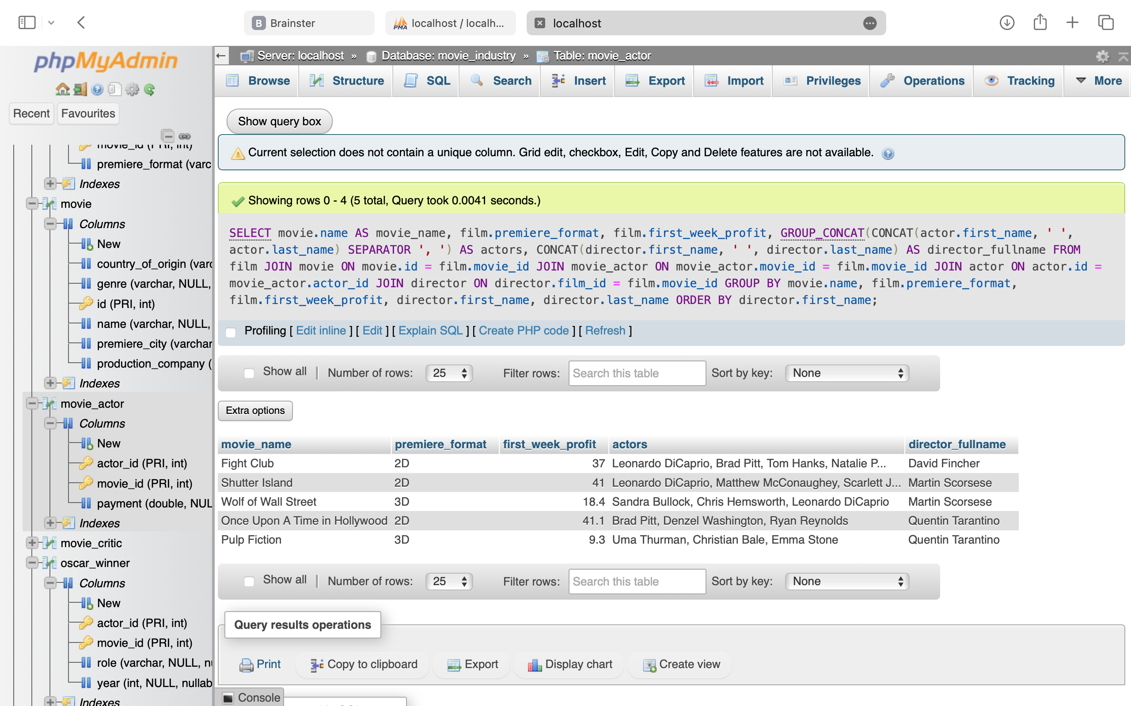

**7. List all information about the actors who have a lower-than average grade given by the critics, and order them from highest to lowest**

WITH actor_avg_grades AS (

SELECT actor_critique.actor_id, actor.first_name, actor.last_name, actor.nickname,

(AVG(actor_critique.acting_grade) + AVG(actor_critique.expression_grade) +

AVG(actor_critique.naturalness_grade) + AVG(actor_critique.devotion_grade)) / 4

AS avg_grade

FROM actor_critique

JOIN actor ON actor.id = actor_critique.actor_id

GROUP BY actor_critique.actor_id, actor.first_name, actor.last_name, actor.nickname

),

overall_avg_grade AS (

SELECT AVG((actor_critique.acting_grade + actor_critique.expression_grade +

actor_critique.naturalness_grade + actor_critique.devotion_grade) / 4) AS overall_avg

FROM actor_critique

)

SELECT actor_id, first_name, last_name, nickname, avg_grade

FROM actor_avg_grades

WHERE

actor_avg_grades.avg_grade < (SELECT overall_avg FROM overall_avg_grade)

ORDER BY

actor_avg_grades.avg_grade DESC

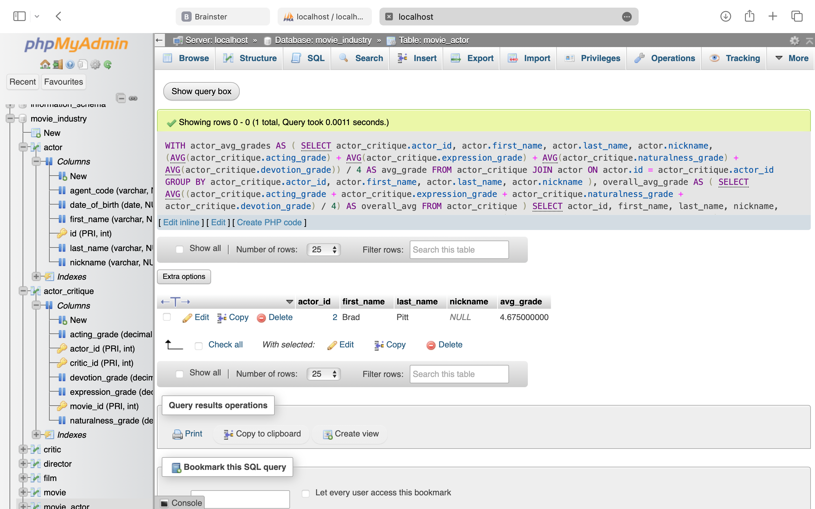

**8. WITH actor_age AS (**

SELECT actor.id, actor.first_name, actor.last_name, actor.date_of_birth,

YEAR(CURDATE()) - YEAR(actor.date_of_birth) AS age

FROM actor

),

average_age AS (

SELECT AVG(YEAR(CURDATE()) - YEAR(actor.date_of_birth)) AS avg_age

FROM actor

)

SELECT first_name,last_name,date_of_birth, age, oscar_winner.role, oscar_winner.year AS winning_year

FROM actor_age

JOIN oscar_winner ON oscar_winner.actor_id = actor_age.id

WHERE actor_age.age > (SELECT avg_age FROM average_age)

List all Oscar winners who are older than the average age of all actors

